|  |
| --- |
|  |
|  |
| CollageEase. |
|  |
|  |
|  |
|  |
| OMAR MOAHMMED OMAR BA WAZIR |
|  |
|  |
|  |
|  |
|  |
| Bachelor of computer science |
|  |
| UNIVERSITI MALAYSIA PAHANG  AL-SULTAN ABDULLAH |
|  |

UNIVERSITI MALAYSIA PAHANG AL-SULTAN ABDULLAH



DECLARATION OF THESIS AND COPYRIGHT

|  |  |  |
| --- | --- | --- |
| Author’s Full Name | : | OMAR MOHAMMED OMAR BA WAZIR |
| Date of Birth | : | 23/12/2001 |
| Title | : | CollageEase |
| Academic Session | : | Semester I 2023/ 2024 |

I declare that this thesis is classified as:

|  |  |  |
| --- | --- | --- |
|  | CONFIDENTIAL | (Contains confidential information under the Official Secret Act 1997)* |
|  | RESTRICTED | (Contains restricted information as specified by the organization where research was done)* |
|  | OPEN ACCESS | I agree that my thesis to be published as online open access (Full Text) |

I acknowledge that Universiti Malaysia Pahang Al-Sultan Abdullah reserves the following

rights:

1. The Thesis is the Property of Universiti Malaysia Pahang Al-Sultan Abdullah

2. The Library of Universiti Malaysia Pahang Al-Sultan Abdullah has the right to make copies of the thesis for the purpose of research only.

3. The Library has the right to make copies of the thesis for academic exchange.

Certified by:

|  |  |
| --- | --- |
| _____________________  (Student’s Signature)  __11598441___________________  New IC/Passport Number  Date: | _______________________  (Supervisor’s Signature)  _______________________  Name of Supervisor  Date: |
|  |  |

NOTE : * If the thesis is CONFIDENTIAL or RESTRICTED, please attach a thesis declaration letter.

THESIS DECLARATION LETTER (OPTIONAL)

Librarian,

Universiti Malaysia Pahang Al-Sultan Abdullah,

Lebuh Persiaran Tun Khalil Yaakob,

26300, Gambang, Kuantan, Pahang.

Dear Sir,

CLASSIFICATION OF THESIS AS RESTRICTED

Please be informed that the following thesis is classified as RESTRICTED for a period of three (3) years from the date of this letter. The reasons for this classification are as listed below.

|  |  |
| --- | --- |
| Author’s Name |  |
| Thesis Title |  |
|  |  |
|  |  |
|  |  |
| Reasons | (i) |
|  |  |
|  | (ii) |
|  |  |
|  | (iii) |
|  |  |

Thank you.

Yours faithfully,

_____________________________

(Supervisor’s Signature)

Date:

Stamp:

Note: This letter should be written by the supervisor and addressed to the Librarian, *Universiti Malaysia Pahang* *Al-Sultan Abdullah* with its copy attached to the thesis.



SUPERVISOR’s DECLARATION

I/We* hereby declare that I/We* have checked this thesis/project* and in my/our* opinion, this thesis/project* is adequate in terms of scope and quality for the award of the degree of *Doctor of Philosophy/ Master of Science.

_______________________________  
 (Supervisor’s Signature)

Full Name :

Position :

Date :

_______________________________  
 (Co-supervisor’s Signature)

Full Name :

Position :

Date :



STUDENT’S DECLARATION

I hereby declare that the work in this thesis is based on my original work except for quotations and citations which have been duly acknowledged. I also declare that it has not been previously or concurrently submitted for any other degree at University Malaysia Pahang Al-Sultan Abdullah or any other institutions.



_______________________________  
 (Student’s Signature)

Full Name : OMAR MOHAMMED OMAR BA WAZIR

ID Number : CB20187

Date : 31 Jan 2024

|  |
| --- |
|  |
|  |
| CollageEase |
|  |
|  |
|  |
|  |
| OMAR MOHAMMED OMAR BA WAZIR |
|  |
|  |
| Thesis submitted in fulfillment of the requirements  for the award of the degree of  Doctor of Philosophy/Master of Science |
|  |
|  |
|  |
| Centre for Mathematical Sciences |
|  |
| UNIVERSITI MALAYSIA PAHANG AL-SULTAN ABDULLAH |
|  |
| OCTOBER 2015 |
|  |
|  |

ACKNOWLEDGEMENTS

I would like to express my sincere gratitude to my supervisor Dr. Encik Muhamad Idaham, for their invaluable guidance and support throughout my Final Year Project (FYP). Their expertise, patience, and encouragement have been instrumental in helping me complete my project to the best of my ability.

ABSTRAK

Pendidikan tinggi di Malaysia mengalami lonjakan permintaan, namun pelajar menghadapi cabaran dalam memilih program universiti yang tepat. Ini disebabkan oleh banyak pilihan yang tersedia dan kekurangan sumber berpusat untuk maklumat yang komprehensif. Untuk mengatasi jurang pengetahuan ini, Projek Tahun Akhir (FYP) ini mencadangkan CollageEase, sebuah laman web komprehensif yang membantu pelajar meneroka dan memilih program universiti di Malaysia. CollageEase akan menggabungkan data dari universiti awam dan bukan awam, menyediakan pelajar dengan akses mudah kepada maklumat mengenai program, prasyarat kemasukan, prospek kerjaya, dan banyak lagi. CollageEase akan direka dengan antara muka yang mesra pengguna, memudahkan pelajar menavigasi dan mencari maklumat yang mereka perlukan. Laman web ini juga akan berskala untuk menampung universiti dan ciri-ciri baru yang diperlukan, Memastikan ia kekal terkini dengan landskap pendidikan tinggi yang sentiasa berubah di Malaysia.

ABSTRACT

Higher education in Malaysia is experiencing a surge in demand, yet students face a challenge in selecting the right university programs. This is due to the abundance of options available and the lack of a centralized resource for comprehensive information. To address this knowledge gap, this Final Year Project (FYP) proposes CollageEase, a comprehensive website that helps students explore and select university programs in Malaysia. CollageEase will amalgamate data from public and non-public universities, providing students with easy access to information on programs, admission prerequisites, career prospects, and more. CollageEase will be designed with a user-friendly interface, making it easy for students to navigate and find the information they need. The website will also be scalable to accommodate new universities and features as needed, ensuring that it remains up to date with the ever-changing landscape of higher education in Malaysia.

TABLE OF CONTENT

DECLARATION

TITLE PAGE

ACKNOWLEDGEMENTS ii

ABSTRAK iii

ABSTRACT iv

TABLE OF CONTENT v

LIST OF TABLES viii

LIST OF FIGURES x

LIST OF SYMBOLS xii

LIST OF ABBREVIATIONS xiii

LIST OF APPENDICES xiv

CHAPTER 1 INTRODUCTION 1

1.1 INTRODUCTION 1

1.2 PROBLEM STATEMENT 2

1.2.1 How things should work 2

1.2.2 Primary problem 2

1.2.3 Evidence 2

1.2.4 A solution 2

1.2.5 Benefits of the proposed solution 2

1.3 AIMS AND OBJECTIVE 3

1.3.1 Scope 3

1.4 PROJECT SIGNAFICANT 5

1.5 Thesis Organization 6

CHAPTER 2 LITERATURE REVIEW 7

2.1 INTRODUCTION 7

2.2 REVIEW OF EXISTING SYSTEMS 7

2.3 LITERATURE REVIEW 12

2.4 Mind map 15

CHAPTER 3 METHODOLOGY 16

3.1 3.1 Introduction 16

3.2 3.2 PROJECT MANAGEMENT FRAMEWORK 17

3.3 Agile Methodology: 17

3.3.1 3.2.1 Here are some of the challenges of using Agile methodology: 19

3.5 Limitations 24

3.6 Constraints 24

3.7 Propose Design 25

3.7.1 Context Diagram 25

3.7.2 Use Case Diagram 26

3.7.3 Use Case Description 27

3.7.4 Flowchart 39

3.8 Activity Diagram 43

3.8.1 Registration Activity Diagram 43

3.8.2 Login Activity Diagram 44

3.8.3 Student Activity Diagram 45

3.8.4 Alumni Activity Diagram 47

3.8.5 Staff Admin Activity Diagram 48

3.8.6 Staff Marketing Department Activity Diagram 49

3.9 Package Diagram 50

3.10 Data Design 50

3.10.1 ERD 50

3.10.2 Data Dictionary 51

3.11 GENERAL ARCHITECTURE 56

3.11.1 Application Layer 56

3.11.2 Business Services Layer 66

3.11.3 Middleware Layer 77

3.12 MVC Package Relationship 78

3.13 Proof of Initial Concept 79

3.14 Test Plan 85

3.14.1 Unit Testing 85

3.14.2 User acceptance Testing 86

3.15 Gantt chart 87

CHAPTER 4 88

4.1 Introduction 88

4.2 IMPLEMENTATION 88

4.2.1 Development Tools 88

4.3 Implementation 89

4.3.1 Designing The User Interface with Code 89

4.4 Software Test 92

4.4.1 Unit Test 92

4.4.2 User Acceptance Testing 92

REFERENCES 93

LIST OF TABLES

Table ‎1.1 GER Data from 1993 till 2018 1

Table ‎2.1 LITERATURE REVIEW 12

Table ‎3.1 Advantages of Agile Table 21

Table ‎3.2 Function Requirements Table 22

Table ‎3.3 Non-Functional Requirements Table 23

Table ‎3.4 CollageEaseUser Registration Management System Table 27

Table ‎3.5 CollageEase Admin Management and Data Entry System Table 29

Table ‎3.6 CollageEase User Feedback Management System Table 30

Table ‎3.7 CollageEase Management Community Hub System Table 32

Table ‎3.8 CollageEase Management Donation System Table 34

Table ‎3.9 CollageEase Management Report System Table 36

Table ‎3.10 CollageEase Manage Registration for Interest Table 37

Table ‎3.11 Entity User Data Dictionary Table 51

Table ‎3.12 Entity Admin Data Dictionary Table 52

Table ‎3.13 Entity Program Data Dictionary Table 53

Table ‎3.14 Entity Feedback Data Dictionary Table 53

Table ‎3.15 Entity Report Data Dictionary Table 54

Table ‎3.16 Entity Donation Data Dictionary Table 54

Table ‎3.17 User Registration Management System Boundary Class Table 57

Table ‎3.18 Admin Managementand Data Entry System Boundary Class Table 57

Table ‎3.19 User Feedback Management System Boundary Class Table 60

Table ‎3.20 Management Report System Boundary Class Table 61

Table ‎3.21 Management Community Hub System Boundary Class Table 62

Table ‎3.22 Management Donation System Boundary Class Table 63

Table ‎3.23 Manage Registration for Interest Boundary Class Table 64

Table ‎3.24 User Registration Management System Controller Class Table 67

Table ‎3.25 Management Donation System Controller Class Table 67

Table ‎3.26 User Feedback Management System Controller Class Table 71

Table ‎3.27 Management Report System Controller Class Table 72

Table ‎3.28 Management Community Hub System Controller Class Table 73

Table ‎3.29 Management Donation System Controller Class Table 74

Table ‎3.30 Manage Registration for Interest Controller Class Table 75

Table ‎3.31 Middleware Layer Architecture Description 77

Table ‎4.1 Tolls & Purpose 88

LIST OF FIGURES

Figure ‎2.1 Main Page of Sajjel Website 8

Figure ‎2.2 Remind me feature button 8

Figure ‎2.3 Remind me feature page 8

Figure ‎2.4 Main Page of Mosahseh Website 9

Figure ‎2.5 log in page 10

Figure ‎2.6 Mosahseh forums 10

Figure ‎2.7 Main Pagr of Pqsa1 Website 11

Figure ‎2.8 AI chat bot feature 12

Figure ‎2.9 Mind map 15

Figure ‎3.1 Agile methodology 19

Figure ‎3.2 Agile methodology process 20

Figure ‎3.3 Context Diagram 25

Figure ‎3.4 Use Case Diagram 26

Figure ‎3.5 User Registration Management System Diagram 27

Figure ‎3.6 Admin Management and Data Entry System Diagram 29

Figure ‎3.7 User Feedback Management System Diagram 30

Figure ‎3.8 Management Community Hub System Diagram 32

Figure ‎3.9 Management Donation System Diagram 34

Figure ‎3.10 Management Report System Diagram 36

Figure ‎3.11 Manage Registration for Interest Diagram 37

Figure ‎3.12 Student Flowchart 39

Figure ‎3.13 Alumni Flowchart 40

Figure ‎3.14 Staff Marketing Department Flowchart 41

Figure ‎3.15 Staff Admin Flowchart 42

Figure ‎3.16 Registration Activity Diagram 43

Figure ‎3.17 Login Activity Diagram 44

Figure ‎3.18 Student Activity Diagram 47

Figure ‎3.19 Alumni Activity Diagram 47

Figure ‎3.20 Staff Admin Activity Diagram 48

Figure ‎3.21 Staff Marketing Department Activity Diagram 49

Figure ‎3.22 ERD of CollageEase System 50

Figure ‎3.23 Application Layer Diagram of CollageEase 56

Figure ‎3.24 Business Services Layer Diagram of CollageEase 66

Figure ‎3.25 Middleware Layer Architecture 77

Figure ‎3.26 MVC Package Diagram 78

Figure ‎3.27 Prototype of log in page 79

Figure ‎3.28 Prototype of registration page 79

Figure ‎3.29 Prototype of High school graduates page 80

Figure ‎3.30 Prototype of Master's and postgraduate page 80

Figure ‎3.31 Prototype of Calculator page 81

Figure ‎3.32 Prototype of Commynity Hub page 81

Figure ‎3.33 Prototype of questions and answers page 82

Figure ‎3.34 Prototype of about us page 82

Figure ‎3.35 Prototype of contact us page 83

Figure ‎3.36 Prototype of Uni admin dashboard page 83

Figure ‎3.37 Prototype of Feedback panel page 84

Figure ‎3.38 Prototype of Data minds panel page 84

Figure ‎3.39 Gantt Chart of CollageEase System 87

Figure ‎4.1 Primary resuilt of "Login page" 90

Figure ‎4.2 Primary resuilt of "Homepage" 90

Figure ‎4.3 Primary resuilt of "Calculator page" 91

Figure ‎4.4 Primary resuilt of "New post / thread" 91

Figure ‎4.5 Primary resuilt of "Master University Program" 92

LIST OF SYMBOLS

|  |  |
| --- | --- |
|  |  |
|  |  |
|  |  |
|  |  |
|  |  |
|  |  |
|  |  |
|  |  |
|  |  |
|  |  |
|  |  |
|  |  |

LIST OF ABBREVIATIONS

|  |  |
| --- | --- |
| SBPWM | Simple Boost Pulse Width Modulation |
| ZSI | Z source inverter |
|  |  |
|  |  |
|  |  |
|  |  |
|  |  |
|  |  |
|  |  |
|  |  |
|  |  |

LIST OF APPENDICES

Appendix A: Title **Error! Bookmark not defined.**

Appendix B: Title **Error! Bookmark not defined.**

# INTRODUCTION

## INTRODUCTION

Higher education in Malaysia is experiencing a surge in demand, yet students face a challenge in selecting the right university programs. This is due to the abundance of options available and the lack of a centralized resource for comprehensive information.

To address this knowledge gap, this Final Year Project (FYP) proposes CollageEase, a comprehensive website that helps students explore and select university programs in Malaysia. CollageEase will amalgamate data from public and non-public universities, providing students with easy access to information on programs, admission prerequisites, career prospects, and more.

CollageEase will be designed with a user-friendly interface, making it easy for students to navigate and find the information they need. The website will also be scalable to accommodate new universities and features as needed, ensuring that it remains up to date with the ever-changing landscape of higher education in Malaysia.(Hamid, 2021)

To provide a snapshot of the demand for higher education in Malaysia, table 1.1 show that this project will incorporate Gross Enrolment Ratio (GER) data:

Table ‎1.1 GER Data from 1993 till 2018

|  |  |
| --- | --- |
| YEAR | Gross enrolment ratio (GER) in tertiary education (%) |
| 1993 | 9.4 |
| 1998 | 22.0 |
| 2003 | 33.8 |
| 2008 | 40.6 |

## PROBLEM STATEMENT

### How things should work

Students should have access to a centralized resource that provides comprehensive information on university programs in Malaysia, including admission prerequisites, career prospects, and student reviews. This resource should be easy to use and navigate, and it should be updated regularly to reflect the latest changes in the Malaysian higher education landscape.

### Primary problem

The lack of a centralized resource for comprehensive information on university programs in Malaysia leads to students making uninformed decisions about their higher education. This can have a negative impact on students' academic and career success, as they may choose programs that are not a good fit for their interests or abilities, or they may not be prepared for the rigor of the program.

### Evidence

According to a study by the Malaysian Ministry of Education, 50% of students who change their university programs do so because they were not satisfied with their original choice. This suggests that many students are making uninformed decisions about their higher education.

### A solution

The proposed solution to this problem is CollageEase, a comprehensive website that provides students with easy access to information on university programs in Malaysia. CollageEase will aggregate data from both public and non-public universities, providing students with a single source of truth for information on programs, admission prerequisites, career prospects, and more.

### Benefits of the proposed solution

CollageEase will offer several benefits to students, including:

* Making it easier for students to research and compare university programs.
* Helping students make informed decisions about their higher education.
* Saving students time and effort.
* Providing students with a more holistic view of university programs, including admission prerequisites, career prospects, and student reviews.

## AIMS AND OBJECTIVE

These objectives aim to understand the current state of university program selection in Malaysia, including the challenges faced by students and the resources that are available to them. This knowledge will be used to inform the development of a comprehensive website to help Malay students select university programs.

To achieve this objective, a comprehensive literature review will be conducted to identify the key challenges faced by students in Malaysia when selecting university programs.

1. To study information about university programs in Malaysia, encompassing both public and non-public institutions.
2. To design a user-friendly website interface and navigation system and ensure scalability for future expansion.
3. To test data from both public and non-public universities, providing students with accurate and up-to-date information.

### Scope

This project will develop a comprehensive website, CollageEase, to help students in Malaysia explore and select university programs. The website will aggregate data from both public and non-public universities, providing students with easy access to information on programs, admission prerequisites, career prospects, and more.

The scope of this project includes the following:

**Literature review:** Conduct a comprehensive literature review to identify the key challenges faced by students in Malaysia when selecting university programs.

**Data collection:** Gather information about university programs in Malaysia, encompassing both public and non-public institutions. This information will include program descriptions, admission prerequisites, career prospects, and student reviews.

**Website development:** Design and develop a user-friendly website interface and navigation system. The website should be scalable to accommodate future expansion, accommodating additional universities and features.

**Data integration:** Integrate data from both public and non-public universities into the website. Ensure that the data is accurate and up to date.

**Testing:** Test the website thoroughly to ensure that it is functioning properly, and that the information is accurate and complete.

**Deployment:** Deploy the website to a production environment so that students can access it.

1. **Student**
2. Ability to manage their registration details within the system, including updating personal information.
3. Ability to browse and search for university programs and to compare different programs.
4. Ability to provide feedback on courses, events, or services offered by the community.
5. Access to the management community hub for information on student-related events, resources, and forums.
6. Ability to register interest in specific university or events.
7. **Alumni**
8. Ability to manage their registration details within the system, including updating personal information.
9. Ability to update personal and professional information post-graduation for networking opportunities.
10. Access to the alumni section of the community hub for events and helping students.
11. Ability to provide feedback on alumni services and community engagement.
12. Ability to make suggestions to the administration.
13. Ability to register interest in specific university or events.
14. **Staff Marketing Department**
15. Ability to manage and update marketing content and data within the system.
16. Access to user feedback management to understand the community's reception of marketing initiatives.
17. Utilization of the management community hub to disseminate marketing materials, announcements, and engage with the community.
18. Ability to generate and analyze reports on marketing campaigns' performance and community engagement levels.
19. **Staff Admin**
20. Comprehensive access to user registration management for oversight and administrative adjustments.
21. Ability to authorize various levels of access to users, based on their roles within the system.
22. Full access to admin management and data entry to ensure all system information is current and accurate.
23. Management of user feedback, including the resolution of issues and implementation of improvements based on feedback.
24. Engagement with the management community hub to oversee community interactions and maintain a positive community environment.
25. Management of donations, ensuring proper allocation, record-keeping, and reporting of financial contributions.
26. Responsibility for generating detailed management reports that may include user statistics, financial reports, and activity logs.
27. Administration of interest registrations, organizing events or initiatives that reflect the community's interests and needs.

## PROJECT SIGNAFICANT

This project is significant because it has the potential to make a positive impact on the lives of many students by helping them make informed decisions about their higher education. CollageEase will be a valuable resource for students, their parents, and educators, providing them with the information they need to choose the right university program and achieve their academic and career goals.

CollageEase can also benefit society as a whole by:

• Increasing the number of students who graduate from university with the skills and knowledge they need to succeed in the workforce.

• Reducing the number of students who drop out of university or switch programs due to dissatisfaction.

## Thesis Organization

The proposed thesis, titled "CollageEase: A Comprehensive Website to Facilitate Informed University Program Selection in Malaysia," addresses the growing demand for higher education in Malaysia while recognizing the challenges students face in choosing suitable programs amidst a plethora of options. The absence of a centralized resource for comprehensive information often results in uninformed decisions, impacting academic and career success. The thesis introduces CollageEase, a user-friendly website aggregating data from both public and non-public universities. Its objectives include conducting a literature review on challenges faced by Malaysian students, gathering comprehensive information on university programs, designing a scalable website interface, integrating accurate data, and thorough testing before deployment. The project caters to the needs of various users—students, administrators, and staff—with safety measures in place. The significance lies in CollageEase's potential to positively impact students' lives by fostering informed decision-making, potentially increasing graduation rates, and reducing program switches, thus contributing to societal progress.

# LITERATURE REVIEW

## INTRODUCTION

Chapter 2 is about the review of existing websites. Three existing websites were explained in detail and compare. The comparisons will focus on the description of the system, features, strength, weakness, advantages, disadvantages, software used, and database tools. The comparisons are made to ensure that it the developed will be in this project is a better.

## REVIEW OF EXISTING SYSTEMS

In this section, three existing websites will be reviewed. These three websites are Sajjel, Mosahseh and Pqsa2.

Sajjel

Sajjel is a comprehensive website that helps students explore and select university programs with a user-friendly interface and navigation system. it aggregates data from public and private universities, providing students with easy access to that university based on it they shall search for the programs they need and admission prerequisites. Figure 2.1 shows a picture of the main page of the website.

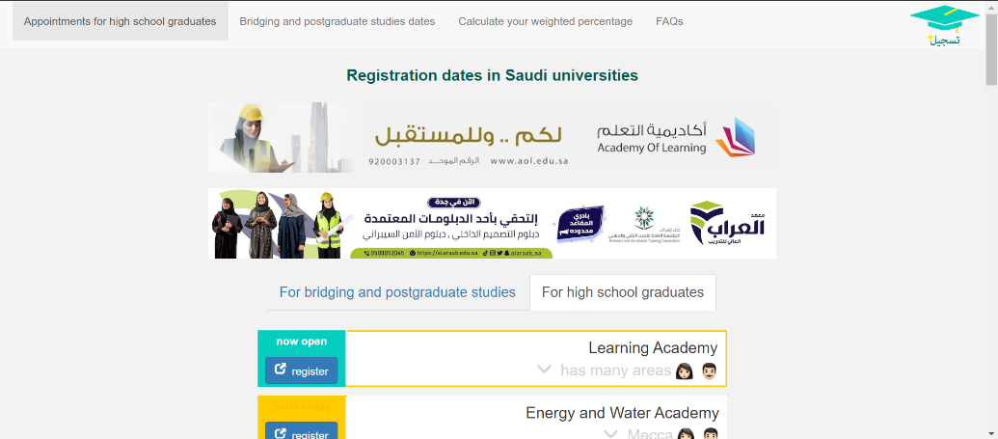

Figure ‎2.1 Main Page of Sajjel Website

Source: (*مواعيد الجامعات ١٤٤٥*, n.d.)

Figure 2.2 show and 2.3 one of the features of the website a service "Remind me" is a message at the beginning of registration and a message before its end on the email of the user. Last but not least Sajjel provides you with a calculator to calculate your GPA.

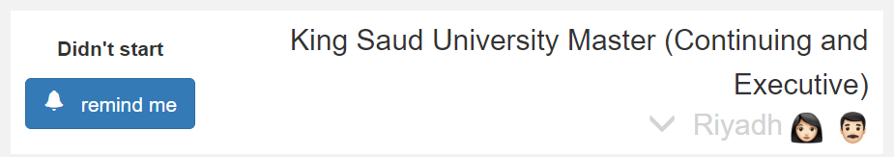

Figure ‎2.2 Remind me feature button

Source: (*مواعيد الجامعات ١٤٤٥*, n.d.)

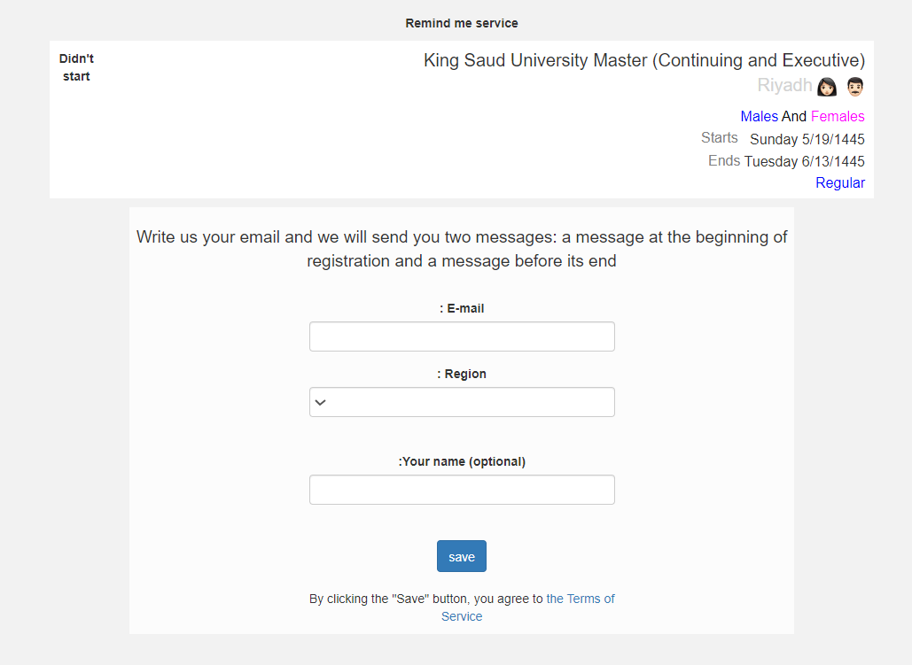

Figure ‎2.3 Remind me feature page

Source: (*مواعيد الجامعات ١٤٤٥*, n.d.)

Support languages and reliability are two key advantages for this website. Support languages enable it to reach a wider audience and improve customer satisfaction. Reliability saves business money and time by reducing customer churn and enhancing brand reputation. However, one weakness of the website is that its content can be outdated, while its social media content is updated more frequently.

This website is built using the PHP programming language and the Laravel framework. Laravel is a PHP framework that provides a variety of features and tools to make web development easier and more efficient. Also, the website also uses SQL for database management.

Mosahseh

Mosahseh is a website that provides up-to-date information about university programs in Saudi. It also offers high performance in searching part to help students find programs that align with their interests and skills. The User-friendly interface and navigation system do not meet the requirements of usability and adaptability. Figure 2.4 shows a picture of the main page of the website. One of the features that is helpful is the website it offers lightning-fast login Figure 2.5 represent that.

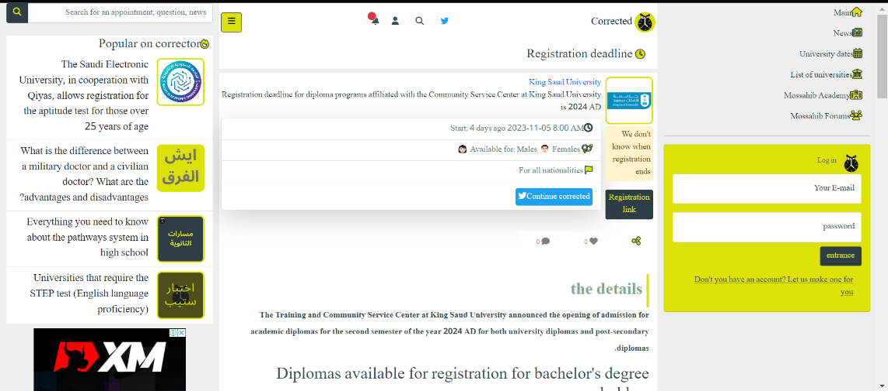

Figure ‎2.4 Main Page of Mosahseh Website

Source: (*مواعيد الجامعات | مصحصح للجامعات*, n.d.)

This website offers several key advantages to its users, this website has three key advantages. Figure 2.6 display the page of "the latest university and education news in Saudi Arabia". A simple question-and-answer chat feature, and reliable performance. Fast access, easy interaction, and trustworthiness make it a great choice for your online needs. These three benefits together make this website a top choice for a seamless and dependable online experience.

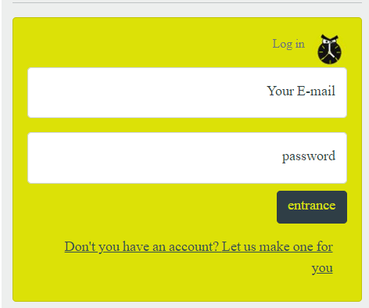

Figure ‎2.5 log in page

Source: (*مواعيد الجامعات | مصحصح للجامعات*, n.d.)

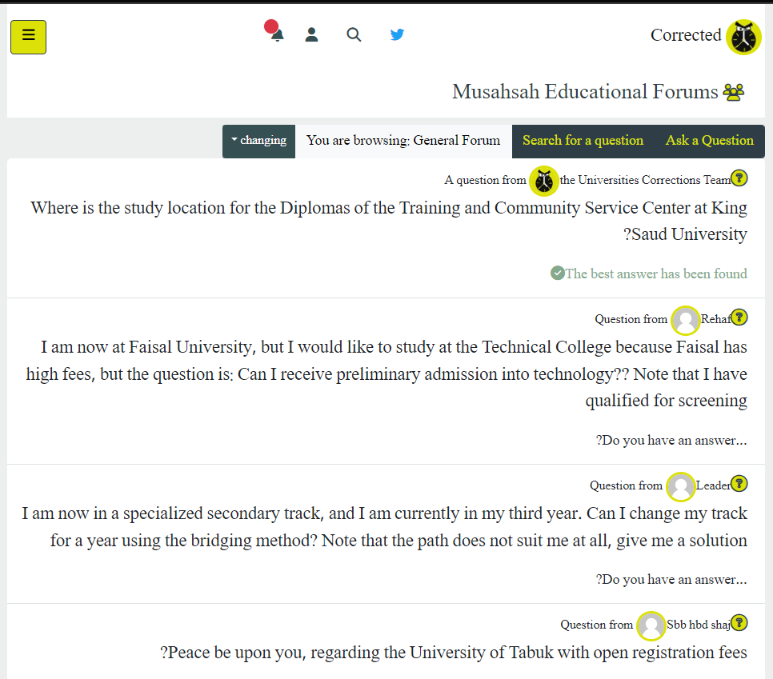

Figure ‎2.6 Mosahseh forums

Source: (*مواعيد الجامعات | مصحصح للجامعات*, n.d.)

A website can be frustrating for users if it has complicated navigation. this is the primary disadvantage of this website. It makes it tough for people to find what they need, leads to confusion with too many options, and can slow down the site, all of which can drive users away.

Mosahseh website is built on a foundation of two key elements. Python and JavaScript are the backbone of software tools, enabling it to create responsive and interactive web applications. Meanwhile, the PostgreSQL database provides a robust and efficient storage solution for managing and retrieving data.

Pqsa2

Pqsa2is a website that provides a variety of resources to help students with their university program selection and courses for some programs and calculator tools. The difference between this website and others is an AI chat tool. Figure 2.7 shows a picture inside the website.

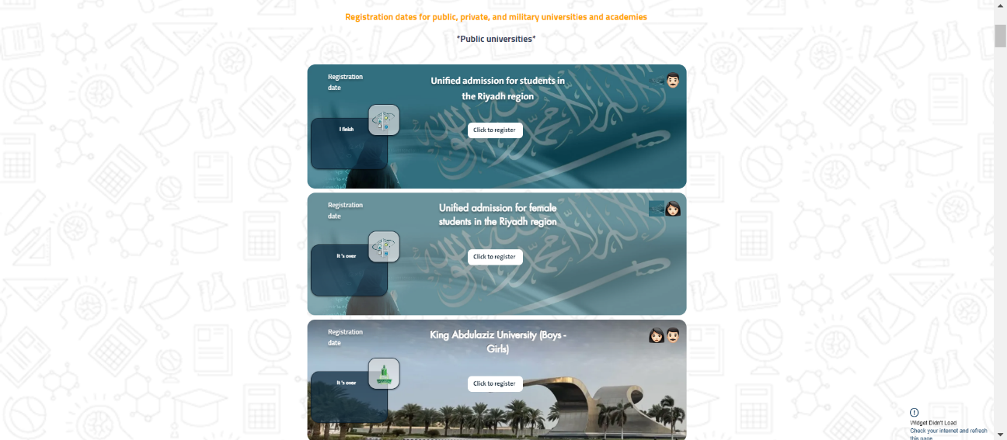

Figure ‎2.7 Main Pagr of Pqsa1 Website

Source: (*مواعيد الجامعات 2023... سلسلة فهد البابطين*, n.d.)

Pqsa2 has the most well-designed website and high quality of usability which is count as powerful strength. Moreover, the website provides AI chatting tool which other two websites do not have it which make it unique thing.

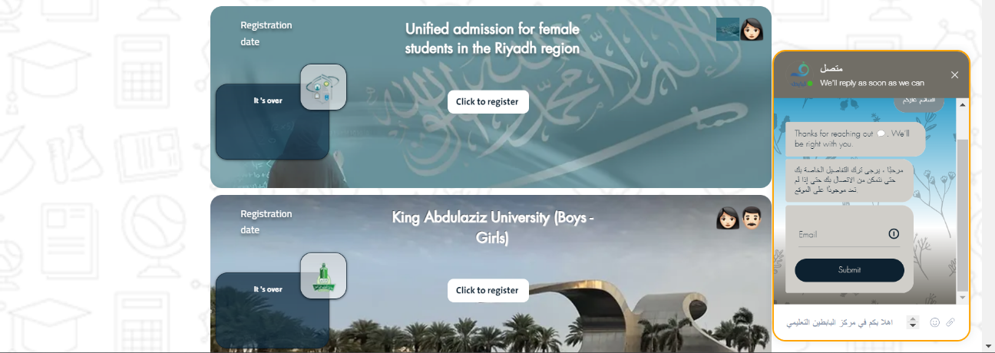

Figure ‎2.8 AI chat bot feature

Source: (*مواعيد الجامعات 2023... سلسلة فهد البابطين*, n.d.)

The website utilizes PHP and jQuery as essential software tools to enhance user interactivity and functionality. In terms of database management, PostgreSQL is the chosen solution. It offers a secure and efficient data storage system, ensuring reliability and data security for the website.

## LITERATURE REVIEW

There are many types of CollageEase systems, and each system has its system flow. There are systems which similar to my project: for example, Mosahseh, Sajjel, Pqsa2. In this chapter we have choose three system to compared with each other, These systems names:

Mosahseh website.

Sajjel website.

Pqsa2 website.

Table ‎2.1 LITERATURE REVIEW

|  |  |  |  |
| --- | --- | --- | --- |
| Attributes | Mosahseh website | Sajjel website | Pqsa2 website |
| Description | Mosahseh is a website platform. University Corrector is a service and search engine for university information, and registration dates to help students not to miss any registration date at any university or study program. | Sajjel is a website platform. It focuses on Registration dates at public and private universities. | It is a wesbite for students to register by data in both public and non-public univeristies beside diffrenet programs to subscipe. |
| Features of each website | 1. Search Part: This is a search function that allows users to look for specific information or content within the system.  2. High Different Resources: These are a wide variety of learning materials, which can include textbooks, articles, and other educational content.  3. GPA/CGPA Calculator: This is a tool that helps students calculate their Grade Point Average (GPA) and Grade Point Average (CGPA) based on the grading system used by a specific university.  4. Education News: This section provides the latest news and updates related to universities and the education system in Saudi Arabia. It keeps users informed about recent events, and changes in the education sector. | 1. Service Reminds Me: This feature sends you email reminders when the registration begins and closes by notifying you through email messages.  2. GPA and CGPA calculator: An online tool that helps students determine their Grade Point Average (GPA) and Grade Point Average (CGPA).  3. Advertise with Us: This is an invitation for businesses or individuals to promote their products, services, or messages through advertising on a platform, website, or media outlet. It offers a channel for reaching a broader audience.  4. Q&A: A platform or section where users can see the most common question that has been asked. | 1. AI chat: A computer-based system that engages in text-based conversations with users.  2. Course programs: Structured sets of educational classes to teach specific subjects or skills on payment.  3. High different resources: A wide range of varied university, programs and courses are available.  4.GPA and CGPA calculator: An online tool that helps students determine their Grade Point Average (GPA) and Grade Point Average (CGPA). |
| Strength | 1. High performance.  2. Secured.  3. Fast Loading Speed  4.Regular Updates  5. Secured. | 1. High performance.  2. Secured.  3. User-Friendly Navigation  4. Responsive Design  5. Secured. | 1. Secured.  2. well desired  3. User-Friendly Navigation  4. Responsive Design |
| Weakness | 1. User-Friendly Navigation | Outdated Content | 1. High performance. |
| Advantages | Fast login due to high performance.  Support languages.  Provide question and answer chatting.  Reliable | Support languages.  Reliable | Fast login options with google.  Provide AI chatting. |
|  |  |  |  |
| Software used | Python, JavaScript | PHP, Laravel | PHP, jQuery |
| Database tool | PostgreSQL | SQL for Database. | PostgreSQL |

## Mind map

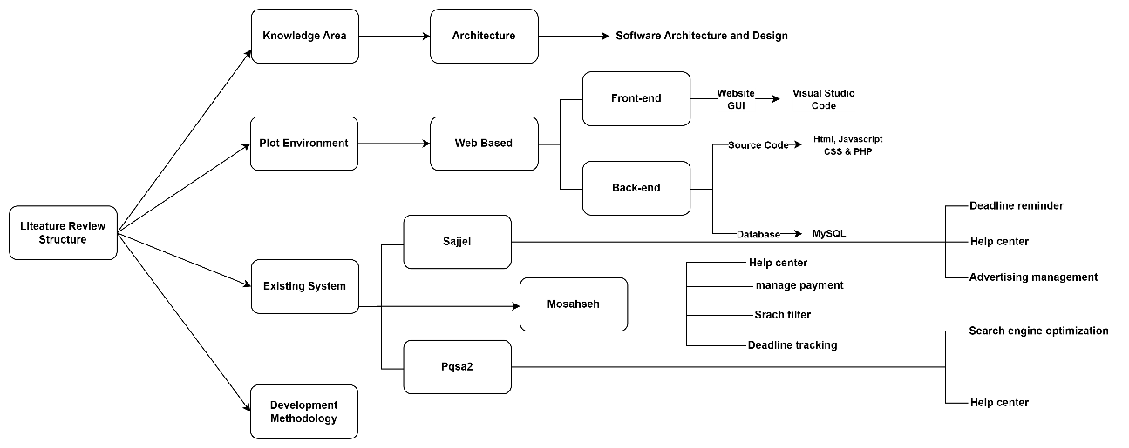

Figure ‎2.9 Mind map

# METHODOLOGY

## 3.1 Introduction

To further advance this method, I have found a suitable technique to be used for the implementation of CollageEase. In this chapter we will discuss the structure of system. At the end of this chapter, the followings will be accomplished in detail.

Software Development Life Cycle (SDLC).

Requirements details

All related diagrams such as context diagram, use case, use case description, and sequence diagram.

Description of how the data will be designed using ERD, and database dictionary.

Designing the prototype.

Describing testing plan and how it will be conducted.

Potential use of the proposed solution

## 3.2 PROJECT MANAGEMENT FRAMEWORK

In this subtopic the methodology that will be used for my system. After few discussions about which methodology we will choose, these three methodologies are suggested to be used.

Agile methodology.

Content management system (CMS).

Rapid Application Development (RAD)

The best methodology process for you would be Agile. Agile is a software development methodology that is based on the following principles:

Individuals and interactions over processes and tools.

Working software over comprehensive documentation.

Customer collaboration over contract negotiation.

Responding to change over following a plan.

These principles make Agile a good choice for projects that have complex or changing requirements, or that need to be completed quickly. Agile also involves users in the development process, which helps to ensure that the website meets their needs.

## Agile Methodology:

In selecting the Agile methodology for my Final Year Project, CollageEase, I am driven by the project's unique characteristics and the need for a flexible and collaborative approach. Agile principles resonate with the dynamic nature of my project, where adaptability, constant collaboration, and responsiveness are crucial.

Firstly, prioritizing 'Individuals and Interactions over Processes and Tools' aligns perfectly with the diverse stakeholders involved students, administrators, and staff. Effective communication and collaboration among team members are prioritized, ensuring that the development process is not only efficient but also responsive to the evolving needs of all users.

Secondly, Working Software over Comprehensive Documentation emphasizes delivering a functional product efficiently. For CollageEase, this means focusing on developing a user-friendly website with core features before extensive documentation. This approach allows for quicker iterations and a more responsive development process.

The Customer Collaboration over Contract Negotiation principle underscores the importance of continuous customer involvement. In the context of CollageEase, this translates into engaging potential users early and consistently throughout development. This collaboration ensures the website closely aligns with user needs and expectations, resulting in a more user-centric final product.

Agile's commitment to 'Responding to Change over Following a Plan' is particularly apt for my project, considering the ever-evolving landscape of higher education in Malaysia. This principle allows my team to adapt promptly to changes in requirements or emerging trends, ensuring CollageEase remains relevant and effective.

Furthermore, Agile's iterative and incremental development approach complements the phased nature of my project conducting a literature review, data collection, website development, and testing. Each iteration allows for adjustments based on feedback and changing requirements.

Lastly, the regular reviews and retrospectives encouraged by Agile provide a mechanism for continuous improvement. These practices ensure that CollageEase remains aligned with user expectations, and my development team can refine strategies based on lessons learned.

### 3.2.1 Here are some of the challenges of using Agile methodology:

1. Requires careful planning: Agile requires careful planning upfront to ensure that the project is successful.
2. Can be difficult to manage: Agile can be more difficult to manage than traditional software development methodologies, as it requires more frequent communication and coordination between team members.

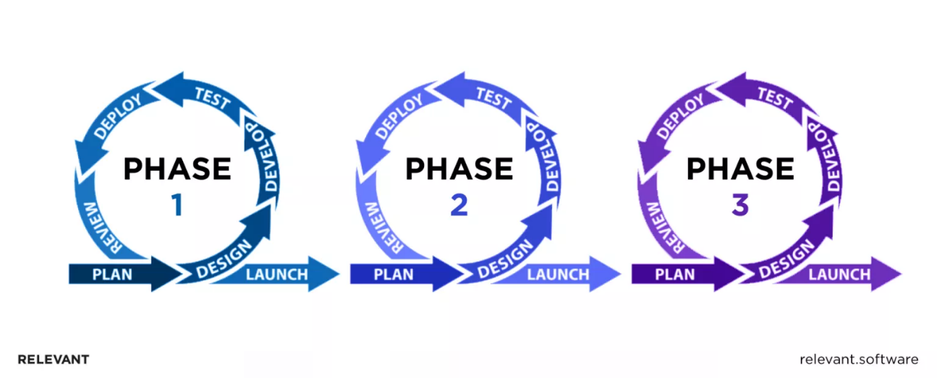

Figure ‎3.1 Agile methodology

Source: (*Agile Software Development Life Cycle, Phases, Tools*, n.d.)

Agile SDLC functions much like a train. Each turning of the train wheels signifies a sprint. During every sprint rotation, new needs are coming in from the backlog, rolling throughout the planning, implementation, testing, analysis, and deployment stages of the Agile software development life cycle (SDLC).

Each Agile stage within every sprint spinning meets the software security monitors through a series of security actions tailored to each phase. There is no need to prevent the train to think about security.

Agile methodology has been widely adopted in software development and IT application development projects since its inception around 1999-2000. The agile approach focuses on adapting to market needs, meeting customer expectations, and accommodating changes as required. This methodology emphasizes delivering value to customers while minimizing the risk of developing products that do not align with market or customer demands.

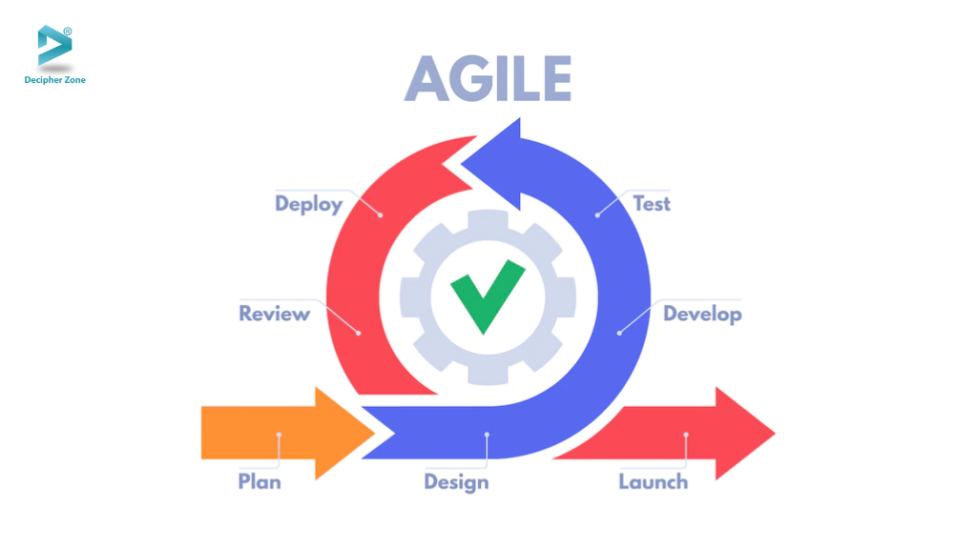

Figure ‎3.2 Agile methodology process

Source: (*6 Stages of the Agile Development Lifecycle*, n.d.)

Table ‎3.1 Advantages of Agile Table

|  |  |
| --- | --- |
| Advantages | Description |
| Increased speed and flexibility | Agile allows you to develop software quickly and efficiently, and to make changes to the software as needed without going through a lengthy and expensive change management process |
| Improved quality | Agile involves users in the development process, which helps ensure that the software meets their needs and that it is of high quality |
| Reduced risk | Agile helps reduce the risk of developing software that does not meet market or customer requirements |
| adaptability to change | Agile helps organizations adapt to change more quickly and effectively than organizations that use traditional software development methodologies |
| System representation | The customer has the opportunity to look at the project, gives early feedback and makes the decision |
| User acceptance testing implementations | At the end of every sprint or iteration, user acceptance testing is conducted |

Source: (*10 Benefits of Using the Agile Methodology*, n.d.)

* 1. **Project Requirement**

Table ‎3.2 Function Requirements Table

|  |  |  |
| --- | --- | --- |
| FUNCTION ID | FUNCTION NAME | DESCRIPTION |
| CE-PR-01 | Authentication | CollageEase must login into the system.  CollageEase have to provide necessary information to complete their registration such as full name, email, and phone number. |
| CE-PR-02 | Browse and search for university programs. | Users should be able to browse and search for university programs by name, keyword, or location. |
| CE-PR-03 | View detailed information about programs | Users should be able to view detailed information about programs, including program descriptions, admission prerequisites, career prospects, and student reviews. |
| CE-PR-04 | Compare different programs | Users should be able to compare different programs side-by-side. |
| CE-PR-05 | Contact universities directly | Users should be able to contact universities directly from the website. |
| CE-PR-06 | Provide feedback or report on the website | Users should be able to provide feedback or report on the website. |

Table ‎3.3 Non-Functional Requirements Table

|  |  |  |
| --- | --- | --- |
| FUNCTION ID | NON-FUNCTION NAME | DESCRIPTION |
| CE-NPR-01 | Easy to use and navigate | The website should be easy to use and navigate, even for users who are not familiar with using websites. |
| CE-NPR-02 | Scalable | The website should be scalable to accommodate future expansion, accommodating additional universities and features. |
| CE-NPR-03 | Responsive | The website should be responsive and work on a variety of devices, including desktops, laptops, tablets, and smartphones. |
| CE-NPR-04 | Secure | The website should be secure and protect user data. |
| CE-NPR-05 | Performant | The website should be performant and load quickly. |
| CE-NPR-06 | Maintainability | Maintainability application should be able to be maintained and accept new features, patch existing features, or delete existing features. |
| CE-NPR-07 | Recoverability | Recoverability application is able to back up the data and recover it if it is lost. |

## Limitations

1. The success of CollageEase heavily relies on the availability and accuracy of data from all kinds of universities. Incomplete or outdated information may limit the effectiveness of the platform in providing comprehensive insights to users.
2. CollageEase deals with sensitive information, including personal details of students and potentially proprietary data from educational institutions. Privacy concerns and data security may pose limitations on the extent of information that can be shared and accessed.

## Constraints

1. Establishing strong collaboration with educational institutions, leveraging official databases, and implementing regular data update protocols can help address this limitation.
2. Implementing robust security measures, adhering to data privacy regulations, and ensuring transparent communication about data handling practices can help address privacy concerns.

## Propose Design

### Context Diagram

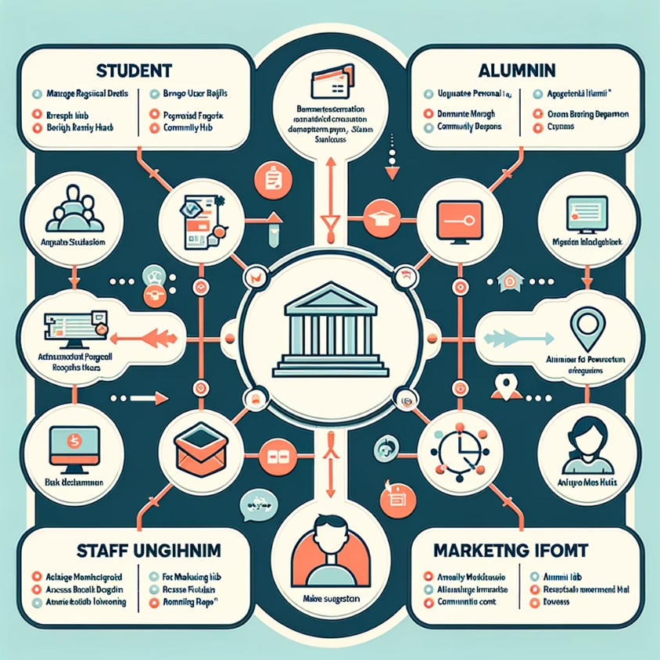

Figure ‎3.3 Context Diagram

### Use Case Diagram

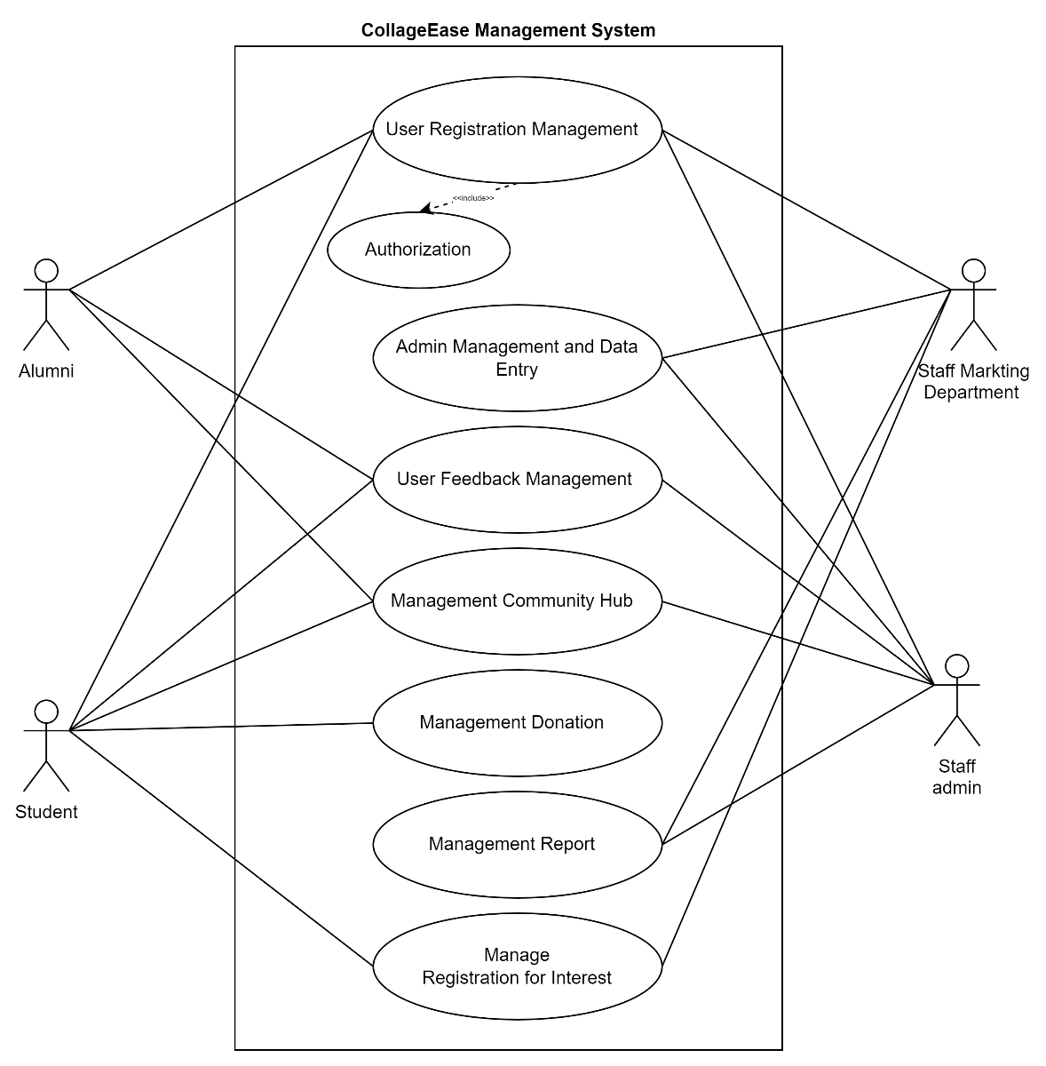

Figure ‎3.4 Use Case Diagram

### Use Case Description

##### User Registration Management

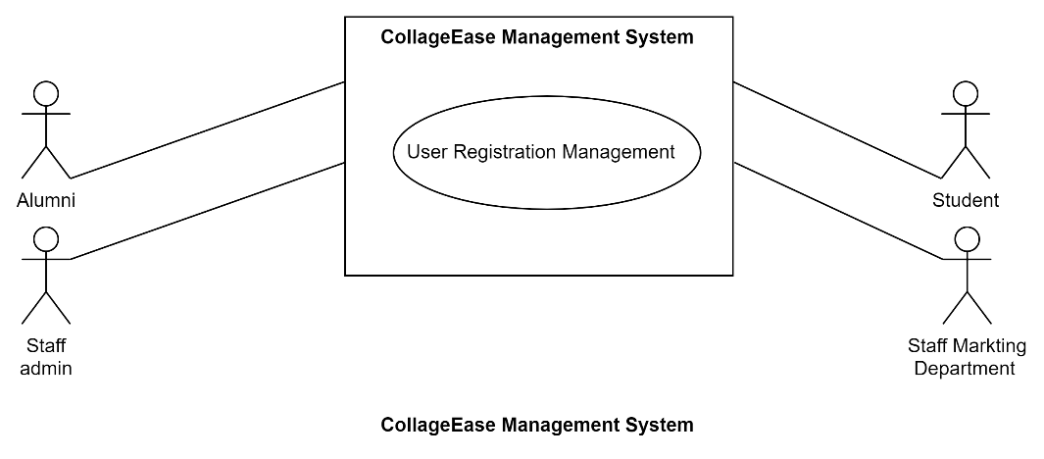

Figure ‎3.5 User Registration Management Diagram

Table ‎3.4 CollageEaseUser Registration Management Table

|  |  |
| --- | --- |
| Use Case ID | CE-UC-01 |
| Brief description | The User Registration Management in CollageEase facilitates the seamless registration of students and users into the platform. This use case involves the process of users creating accounts to access CollageEase features and resources. |
| Actors | Student, Alumni, Staff admin, Staff Marketing Department |
| Pre-condition | The CollageEase system is operational, and the student/user has access to a device with an internet connection. |
| Basic flow | 1. The user opens the CollageEase website. 2. The user clicks on the "Register" button. **[A1]** 3. The system presents the user with a registration form. 4. The user fills in necessary information, including name, email, desired username, and password, etc. 5. The system verifies the uniqueness of the chosen username and validates the email format. 6. If there are issues, the user is prompted to correct the information. 7. The system verifies the uniqueness of the chosen username and validates the email format. **[A2]**, **[A3]** 8. If there are issues, the user is prompted to correct the information. **[E1]** |
| Alternative flow | 1. If the user already registered user can log in into the system without new account. 2. If the chosen username is already in use, the system prompts the user to select a different one. 3. If the email format is incorrect, the system alerts the user to provide a valid email. |
| Exception flow | If there is a system error during the registration process, such as a database connection failure, an error message is displayed, and the user is prompted to try again later. |
| Post-condition | The user's registration details are securely stored in the CollageEase database, and the user gains access to the platform with the provided credentials. |

##### Admin Management and Data Entry

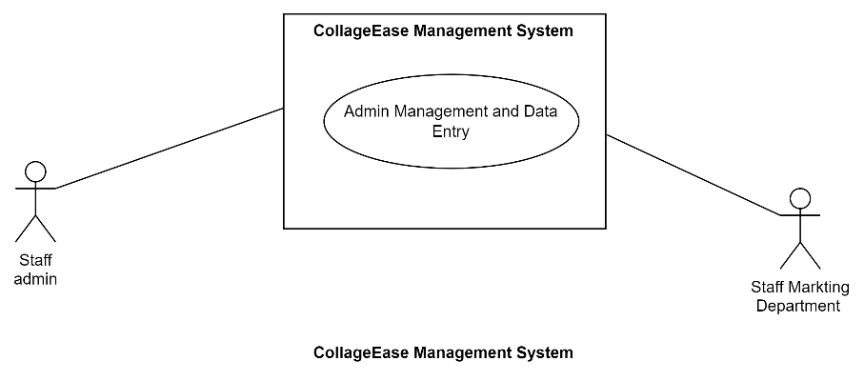

Figure ‎3.6 Admin Management and Data Entry Diagram

Table ‎3.5 CollageEase Admin Management and Data Entry Table

|  |  |
| --- | --- |
| Use Case ID | CE-UC-02 |
| Brief description | The Admin Management and Data Entry in CollageEase facilitates the effective management of administrators and the efficient entry of relevant data into the platform. This use case involves the processes associated with creating, editing, and managing administrator accounts, as well as the entry of essential data into the system. |
| Actors | Staff admin, Staff Marketing Department |
| Pre-condition | The CollageEase system is operational, and the admin/user has appropriate access privileges to perform management and data entry tasks. |
| Basic flow | 1. The user logs into the CollageEase system with valid credentials. 2. The user prompt for entry new data from the menu. **[A1]**, **[E1]** |
| Alternative flow | If the entered admin details during account creation are incomplete or invalid, the system prompts the user to provide correct information. |
| Exception flow | If there is a system error during admin management or data entry, such as a database connection failure, an error message is displayed, and the user is prompted to try the action again. |
| Post-condition | The CollageEase system updates the admin/user database with new entries or modifications, ensuring accurate admin management and maintaining the integrity of the entered data. |

##### User Feedback Management

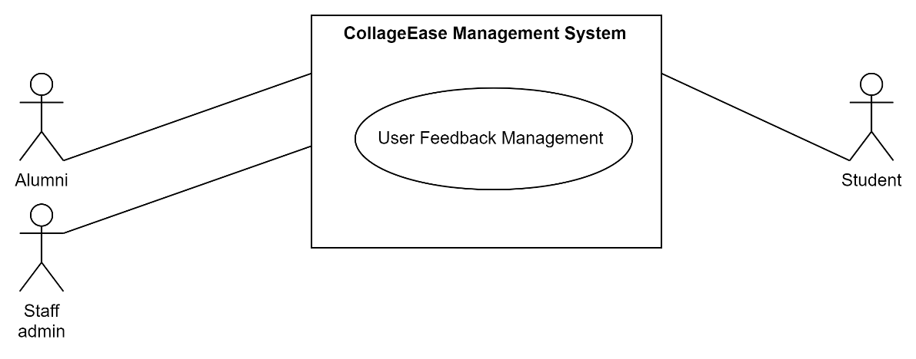

Figure ‎3.7 User Feedback Management Diagram

Table ‎3.6 CollageEase User Feedback Management Table

|  |  |
| --- | --- |
| Use Case ID | CE-UC-03 |
| Brief description | The User Feedback and Support Management in CollageEase oversees the process of users providing feedback and seeking support. It involves the efficient collection, organization, and resolution of user queries or concerns to enhance user satisfaction and improve the platform's performance. |
| Actors | Student, Safety admin, Staff Marketing Department |
| Pre-condition | The CollageEase system is operational, and the user is logged into their account. |
| Basic flow | 1. The system presents options for providing feedback or initiating a support request. 2. The user clicks on the "Feedback" section within CollageEase menu. 3. The user enters relevant details, including the nature of the feedback request and any supporting information. **[A1]** 4. The user submits the feedback request through the system. **[E1]** 5. The system acknowledges the submission and provides a reference or ID number. 6. Staff admin reviews to the user's feedback request. |
| Alternative flow | If the user initiates a support request, the system may prompt them to provide additional details or attachments to facilitate the resolution process. |
| Exception flow | If there is a system error during the submission process, an error message is displayed, and the user is prompted to try again. |
| Post-condition | Non-applicable |

##### Management Community Hub

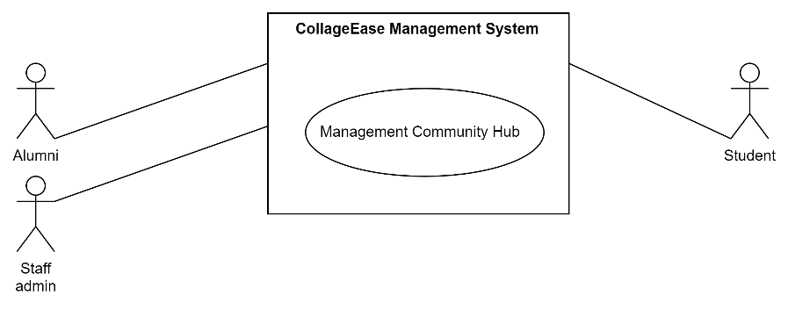

Figure ‎3.8 Management Community Hub Diagram

Table ‎3.7 CollageEase Management Community Hub Table

|  |  |
| --- | --- |
| Use Case ID | CE-UC-04 |
| Brief description | The Management Community Hub within CollageEase oversees the creation and management of community discussions and interactions. This use case involves the facilitation of user engagement within the platform's community hub, fostering collaboration, and providing a space for users to share insights and experiences. |
| Actors | Student, Alumni, Staff admin |
| Pre-condition | 1. The CollageEase system is operational, and the student is logged into their account. 2. The user is already paid for this feature. |
| Basic flow | 1. The user navigates to the "Community Hub" section within the CollageEase menu. 2. The user initiates a new discussion by providing a title, description. **[E1]** 3. The user engages in existing discussions by posting comments, asking questions, or responding to others' contributions. 4. The system facilitates real-time updates, and interactions within the community hub to enhance user engagement. 5. The system allows the user to view, edit, delete, reply, add to the chat. **[A1]** |
| Alternative flow | If a user attempts to post content that violates community guidelines, the system may prompt them to revise or remove the content. |
| Exception flow | If there is a system error during the creation of a new discussion or participation in existing discussions, an error message is displayed, and the user is prompted to try again. |
| Post-condition | Non-applicable |

##### Management Donation

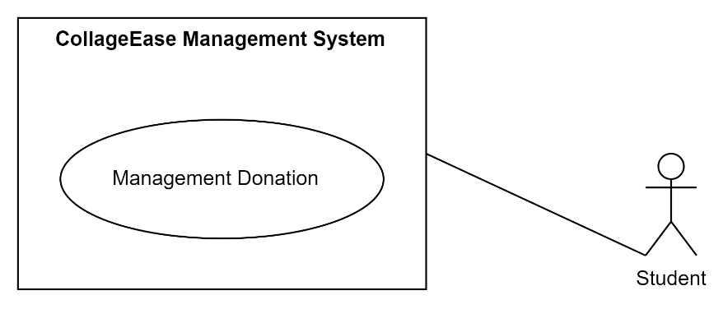

Figure ‎3.9 Management Donation Diagram

Table ‎3.8 CollageEase Management Donation Table

|  |  |
| --- | --- |
| Use Case ID | CE-UC-05 |
| Brief description | The Management Donation within CollageEase facilitates the efficient handling and related to user donation to use Community Hub. |
| Actors | Student |
| Pre-condition | 1. The user has an active account on CollageEase. 2. The user has selected Community Hub service that requires donation to the system. |
| Basic flow | 1. The user selects the Community Hub service for which donation is required. 2. The system presents the user with available payment donation options (QR, bank transfer). **[A1]** 3. The user chooses a preferred payment donation method and provides the necessary details. **[E1]** 4. The Management Donation System securely processes the payment. 5. The system generates a payment donation confirmation and updates the user's records. 6. Simultaneously, the system if receives successful payment donation user may use the service freely. |
| Alternative flow | If the user encounters issues with the selected payment donation method, they can choose an alternative option from the available list. |
| Exception flow | In case of payment donation failure, the system provides clear error messages and prompts the user to rectify the issue or choose another payment donation method. |
| Post-condition | 1. The user receives a payment donation confirmation. |

##### Management Report

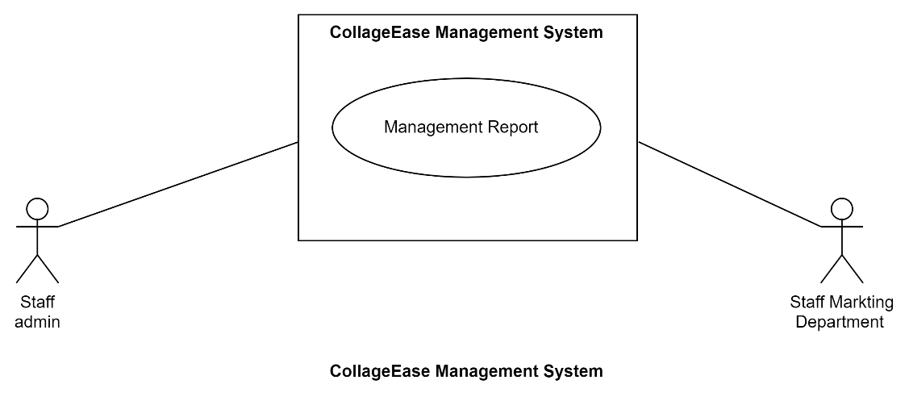

Figure ‎3.10 Management Report Diagram

Table ‎3.9 CollageEase Management Report Table

|  |  |
| --- | --- |
| Use Case ID | CE-UC-06 |
| Brief description | The Management Report in CollageEase serves as a comprehensive tool for generating, analysing, and presenting various reports related to the platform's performance, user engagement, and key metrics. This use case empowers stakeholders, including administrators and decision-makers, to make informed choices based on data-driven insights. |
| Actors | Staff admin, Staff Marketing Department |
| Pre-condition | Staff members in both the Marketing Department and Administration have valid login credentials for CollageEase. |
| Basic flow | 1. Logs into CollageEase and accesses the Management Report System. 2. Selects the category of reports related to marketing performance. 3. The system generates a detailed marketing report based on the configured parameters. 4. Staff in the Marketing Department reviews the report for further analysis and decision-making. |
| Alternative flow | None |
| Exception flow | None |
| Post-condition | Staff members from the Marketing Department and Administration possess relevant reports for marketing and administrative decision-making. |

##### Manage Registration for Interest

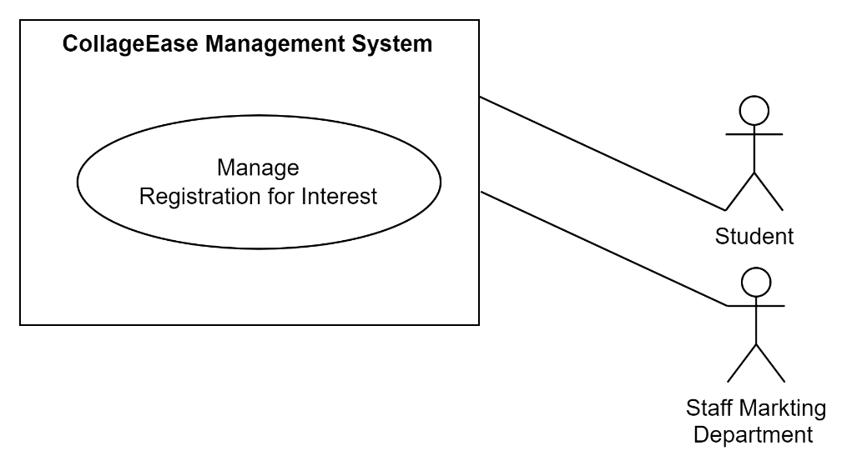

Figure ‎3.11 Manage Registration for Interest Diagram

Table ‎3.10 CollageEase Manage Registration for Interest Table

|  |  |
| --- | --- |
| Use Case ID | CE-UC-07 |
| Brief description | The Manage Registration for Interest use case in CollageEase facilitates the seamless registration process for students expressing interest in a university programs. |
| Actors | Staff admin, Staff Marketing Department |
| Pre-condition | Students and Marketing Department staff have access to CollageEase and valid login credentials. |
| Basic flow | 1. Logs into CollageEase and navigates to the Registration for Interest section. 2. Selects the university programs or areas of interest. 3. Provides necessary information, including contact details and preferred communication methods. 4. Submits the registration form to express interest. 5. Receives a confirmation message upon successful registration. |
| Alternative flow | None |
| Exception flow | None |
| Post-condition | 1. Students successfully express for interest and receive confirmation and wait for the contact. 2. The Marketing Department gains valuable data for personalized communication and marketing strategies. |

### Flowchart

##### Student Flowchart

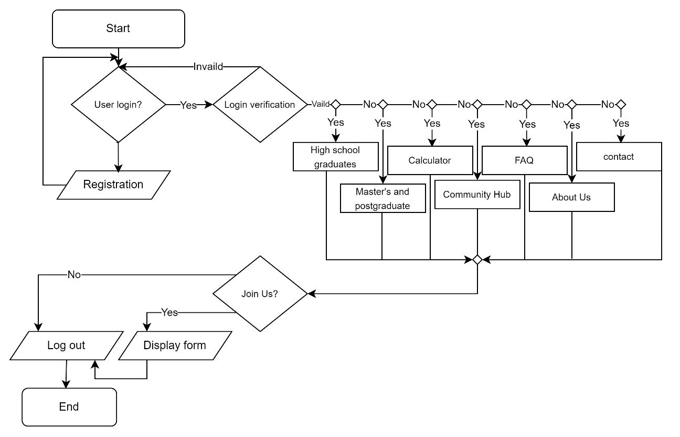

Figure ‎3.12 Student Flowchart

##### Alumni Flowchart

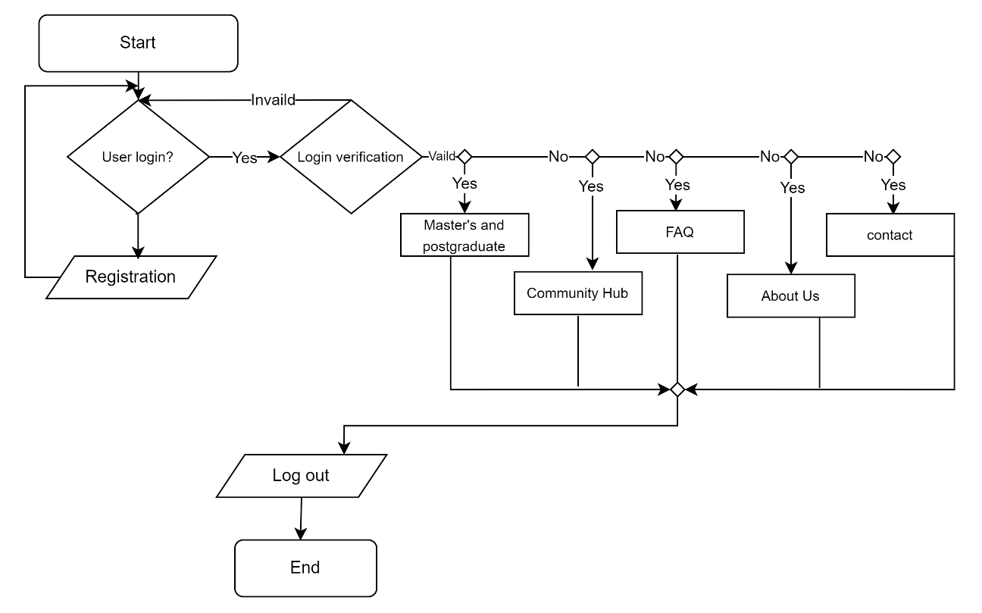

Figure ‎3.13 Alumni Flowchart

##### Staff Marketing Department Flowchart

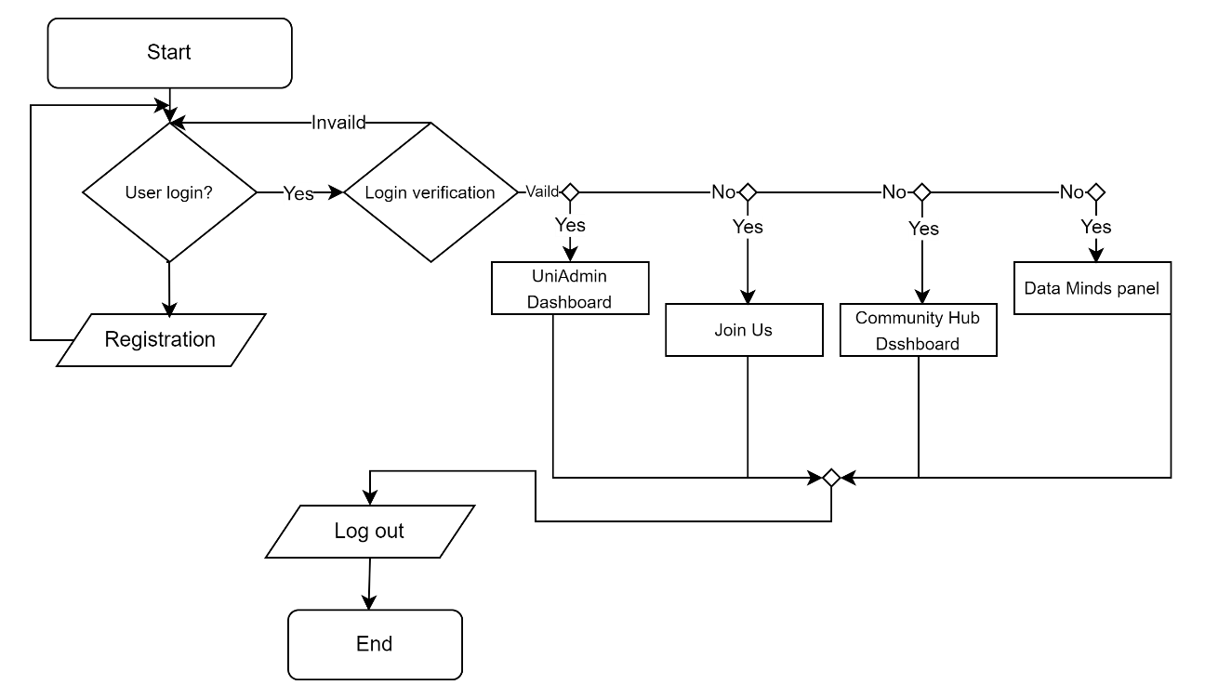

Figure ‎3.14 Staff Marketing Department Flowchart

##### Staff admin Flowchart

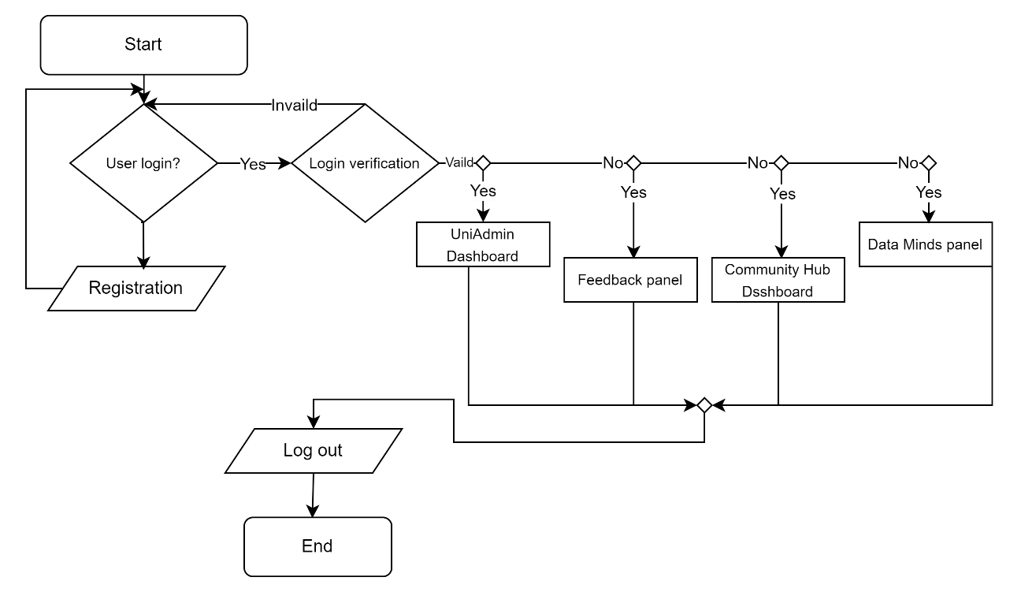

Figure ‎3.15 Staff Admin Flowchart

## Activity Diagram

### Registration Activity Diagram

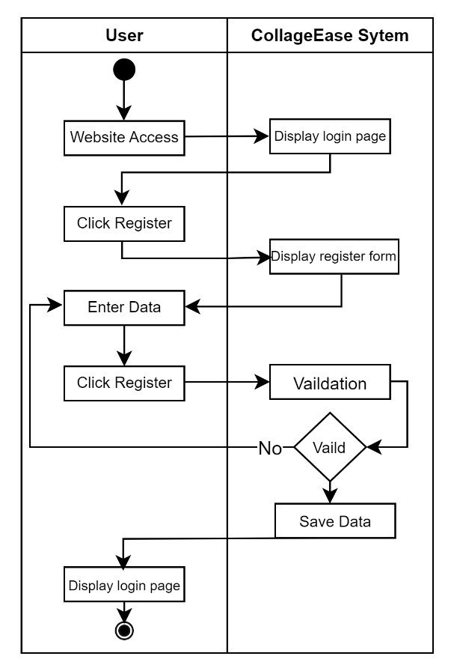

Figure ‎3.16 Registration Activity Diagram

### Login Activity Diagram

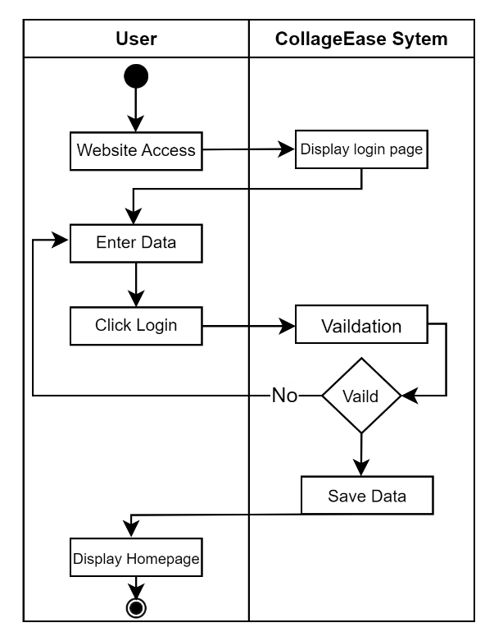

Figure ‎3.17 Login Activity Diagram

### Student Activity Diagram

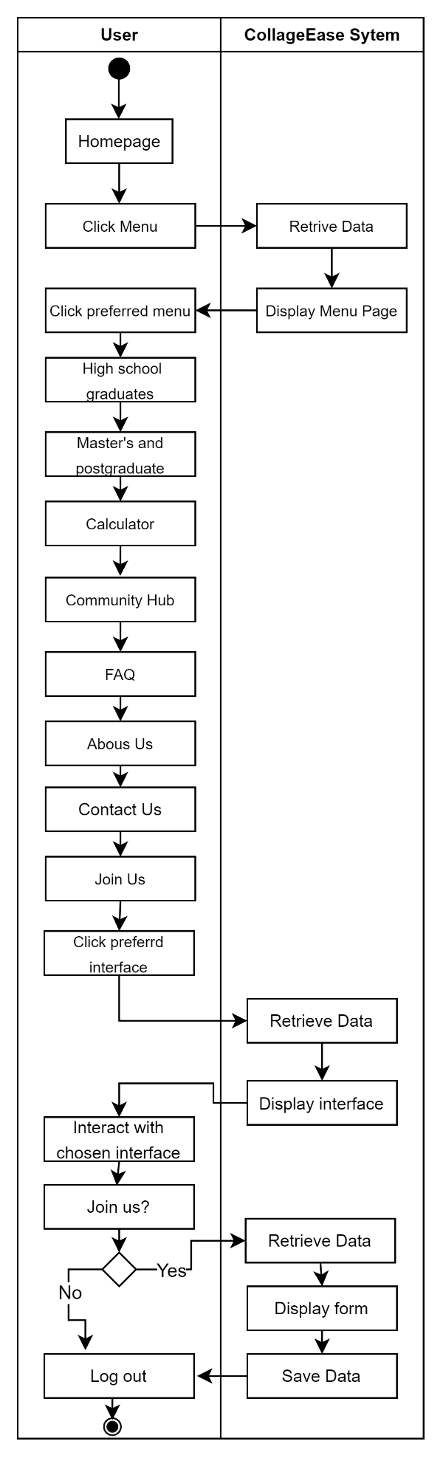

Figure ‎3.18 Student Activity Diagram

### Alumni Activity Diagram

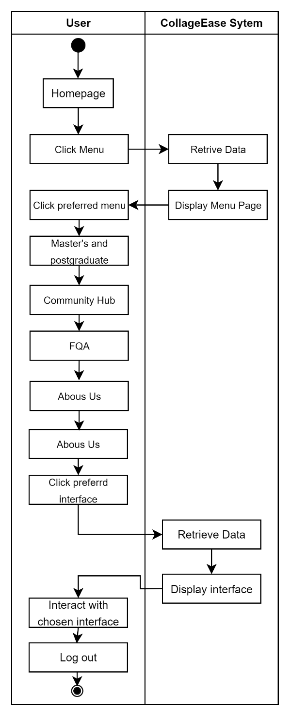

Figure ‎3.19 Alumni Activity Diagram

### Staff Admin Activity Diagram

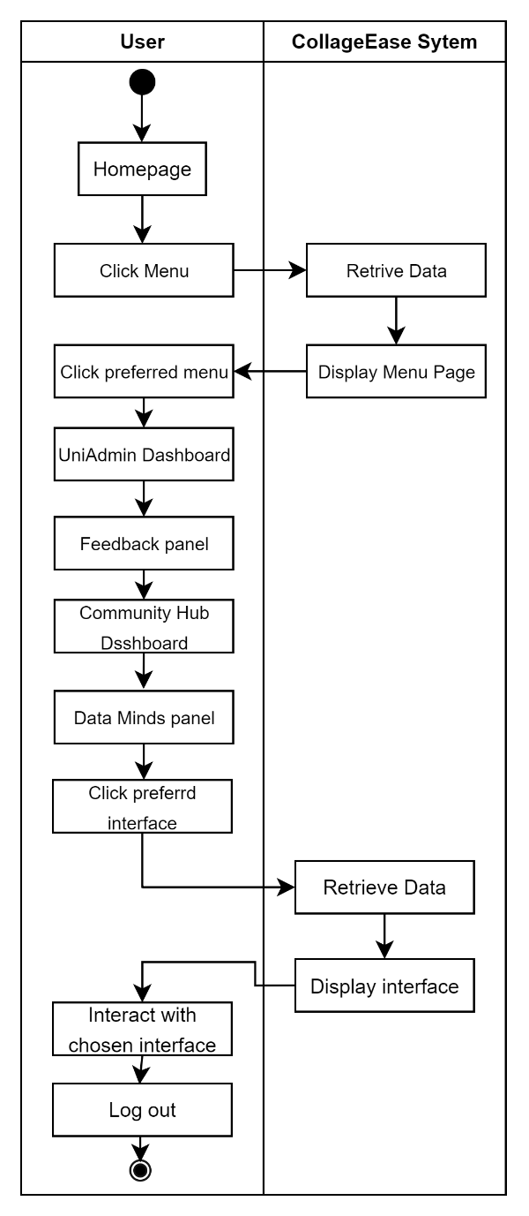

Figure ‎3.20 Staff Admin Activity Diagram

### Staff Marketing Department Activity Diagram

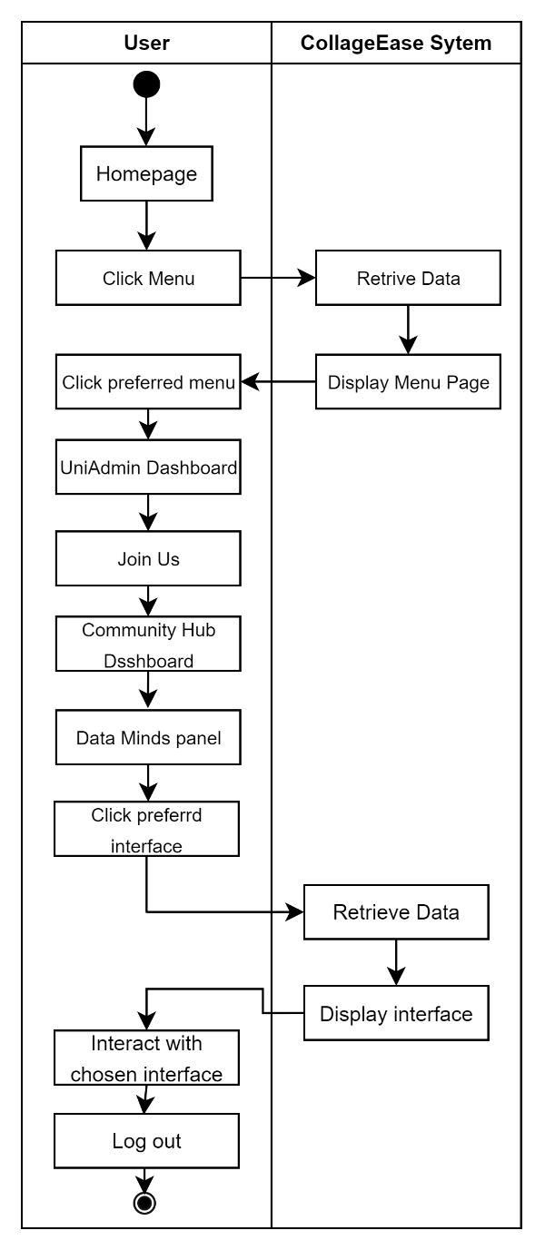

Figure ‎3.21 Staff Marketing Department Activity Diagram

## Package Diagram

## Data Design

### ERD

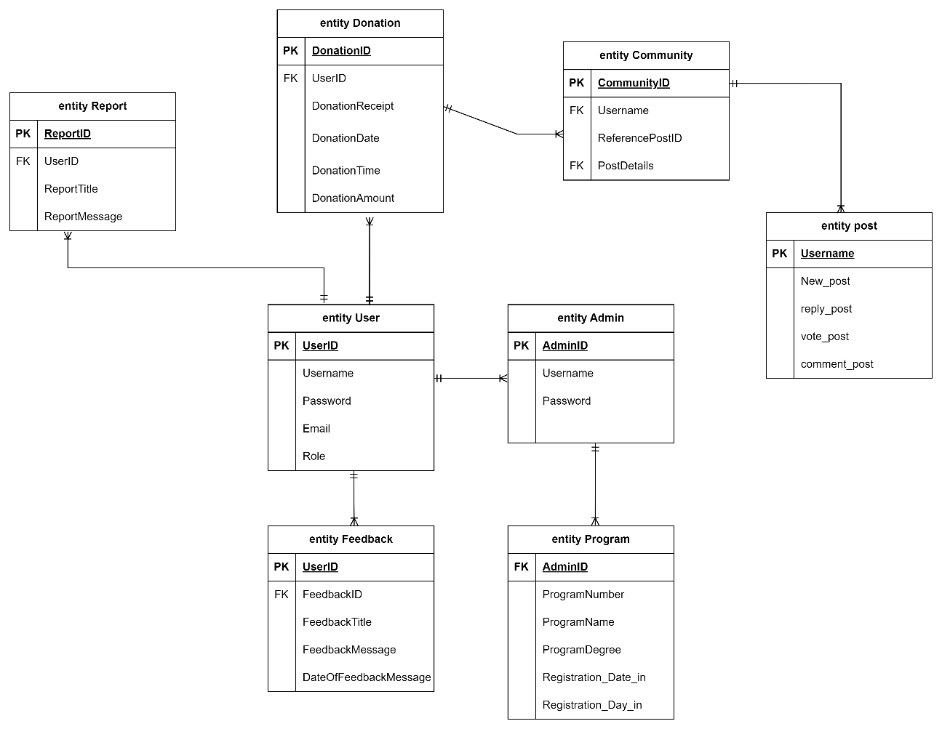

Figure ‎3.22 ERD of CollageEase System

### Data Dictionary

##### Entity User

Table ‎3.11 Entity User Data Dictionary Table

|  |  |  |  |
| --- | --- | --- | --- |
| **Field Name** | **Description** | **Data Type** | **Constraint** |
| Username | The username field represents the unique identifier chosen by an individual to access the CollageEase system. | Varchar (20) | PK, NOT NULL, AUTO-INCREMENT |
| Password | The password field is used to store a secure and confidential string of characters chosen by the user during registration and use to login. | VARCHAR  (10) | NOT NULL |
| Email | The email field stores the user's email address and use to login. | VARCHAR  (50) | NOT NULL |
| Role | The role field defines the user's role within the CollageEase system. | VARCHAR  (10) | NOT NULL |

##### Entity Community

Table ‎3.12 Entity Community Data Dictionary Table

|  |  |  |  |
| --- | --- | --- | --- |
| **Field Name** | **Description** | **Data Type** | **Constraint** |
| Username | The username field represents the unique identifier chosen by an individual to access the CollageEase system. | VARCHAR (20) | PK, NOT NULL, AUTO-INCREMENT |
| ReferencePostID | Unique identifier linking a post to another post | Integer (10) | FK, NOT NULL |
| PostDetails | Additional information and details about a post, including new post, reply post, vote post, and comment post. | VARCHAR  (10) | NOT NULL |

##### Entity post

|  |  |  |  |
| --- | --- | --- | --- |
| **Field Name** | **Description** | **Data Type** | **Constraint** |
| New_post | Indicates the creation of a new post or content | VARCHAR (200) | NULL |
| Reply_post | Represents approval or agreement with a specific reply or comment. | VARCHAR (150) | NULL |
| Vote_post | Reflects user approval or feedback on a particular post or content. | BOOLEAN | NULL |
| Comment_post | Records user comments or feedback on a specific post or content. | VARCHAR (150) | NULL |

##### Entity Admin

Table ‎3.13 Entity Admin Data Dictionary Table

|  |  |  |  |
| --- | --- | --- | --- |
| **Field Name** | **Description** | **Data Type** | **Constraint** |
| AdminID | AdminID is a unique identifier for administrators in CollageEase | VARCHAR (10) | NOT NULL, AUTO-INCREMENT |
| Username | The username field represents the unique identifier chosen by an individual to access the CollageEase system. | VARCHAR (10) | FK, NOT NULL |
| Password | The password field is used to store a secure and confidential string of characters chosen by the user during registration and use to login. | VARCHAR  (10) | NOT NULL |

##### Entity Program

Table ‎3.14 Entity Program Data Dictionary Table

|  |  |  |  |
| --- | --- | --- | --- |
| **Field Name** | **Description** | **Data Type** | **Constraint** |
| AdminID | AdminID is a unique identifier for administrators in CollageEase | VARCHAR (10) | NOT NULL, AUTO-INCREMENT |
| ProgramNumber | Unique identifier for academic programs in CollageEase | INTEGER (10) | FK, NOT NULL |
| ProgramName | Stores the name of academic programs, providing a user reference. | VARCHAR  (20) | NOT NULL |
| ProgramDegree | Indicates the academic degree associated with a program (e.g., Bachelor's, Master's). | VARCHAR  (20) | NOT NULL |
| Registration_Date_in | Records the date of user registration for a program | Date | NOT NULL |
| Registration_Day_in | Captures the day of the week for user program registrations | VARCHAR  (10) | NOT NULL |

##### Entity Feedback

Table ‎3.15 Entity Feedback Data Dictionary Table

|  |  |  |  |
| --- | --- | --- | --- |
| **Field Name** | **Description** | **Data Type** | **Constraint** |
| FeedbackID | is a unique identifier assigned to feedback entries in CollageEase | VARCHAR (10) | PK, NOT NULL, AUTO-INCREMENT |
| FeedbackTitle | stores the title or subject of user feedback within CollageEase | VARCHAR  (30) | NOT NULL |
| FeedbackMessage | contains the detailed message or content of user feedback in CollageEase | VARCHAR  (100) | NOT NULL |
| DateOfFeedbackMessage | records the date when a user submits feedback in CollageEase | Date | NOT NULL |

##### Entity Report

Table ‎3.16 Entity Report Data Dictionary Table

|  |  |  |  |
| --- | --- | --- | --- |
| **Field Name** | **Description** | **Data Type** | **Constraint** |
| UserID | is a unique identifier assigned to users in CollageEase, | VARCHAR  (10) | NOT NULL |
| ReportTitle | stores the title or subject of reports submitted within CollageEase | VARCHAR  (50) | NOT NULL |
| ReportMessage | contains the detailed content or message of reports submitted by users in CollageEase. | VARCHAR  (10) | NOT NULL |

##### Entity Donation

Table ‎3.17 Entity Donation Data Dictionary Table

|  |  |  |  |
| --- | --- | --- | --- |
| **Field Name** | **Description** | **Data Type** | **Constraint** |
| DonationID | Unique identifier for donations in Colla geEase | VARCHAR (10) | PK, NOT NULL, AUTO-INCREMENT |
| UserID | Identifies the user making a donation | VARCHAR  (10) | NOT NULL |
| DonationReceipt | Stores information on the receipt or confirmation of donations | VARCHAR  (50) | NOT NULL |
| DonationDate | Records the date of donation for analysis | VARCHAR  (10) | NOT NULL |
| DonationTime | Captures the time of donation | Date | NOT NULL |
| DonationAmount | Indicates the monetary value of a donation |  |  |

##### Entity Community

## GENERAL ARCHITECTURE

### Application Layer

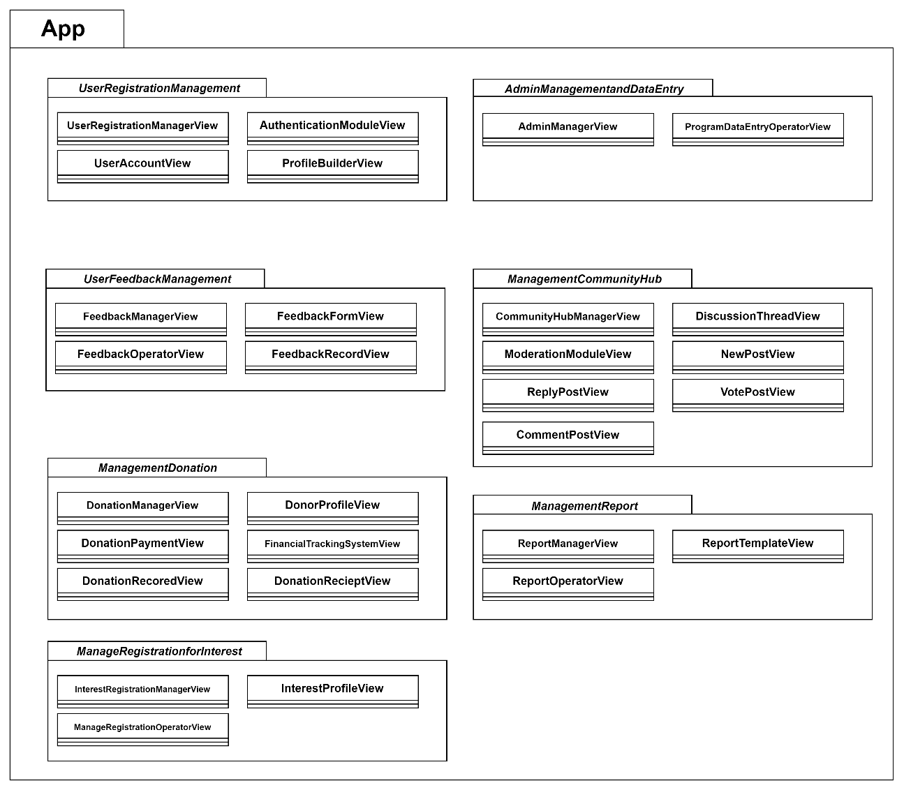

Figure ‎3.23 Application Layer Diagram of CollageEase

Table ‎3.18 User Registration Management Boundary Class Table

|  |  |  |
| --- | --- | --- |
| Class Type | Boundary class | |
| Responsibility | Facilitate the user registration process by interacting with users, collecting registration details, and handling the registration workflow. | |
| Attributes | Attributes Name | Attributes Type |
| Username  Password  Email  Role | Varchar  Varchar  Varchar  Varchar |
| Methods | Method Name | Description |
| collectUserRegistrationDetails()  validateUserRegistrationForm() | Prompt users to provide registration details through the registration form.  Validate user registration data. If issues exist, display user to Homepage. |
| Algorithm | collectUserRegistrationDetails():  registrationForm.promptUserForDetails()  validateUserRegistrationForm():  validationIssues = registrationForm.validateData()  if validationIssues is not empty:  registrationForm.displayValidationIssues(validationIssues)  else:  UserAlreadyRegsitered() | |

Table ‎3.19 Admin Managementand Data Entry System Boundary Class Table

|  |  |  |
| --- | --- | --- |
| Class Type | Boundary class | |
| Responsibility | Handle administrative tasks, manage user roles, oversee data entry processes, manage the community hub, and deal with reports. | |
| Attributes | Attributes Name | Attributes Type |
| Username  Password | Varchar  Varchar |
| Methods | Method Name | Description |
| manageAdminTasks()  processDataEntry(data)  viewReports()  manageCommunityHub()  overseeReports() | * Facilitate administrative tasks and user role changes. * Process data entered by DataEntryOperators. * View various reports generated by the system. * Manage community discussions, events, and members. * Oversee the generation and analysis of reports. |
| Algorithm | manageAdminTasks():  adminPanel.displayAdminOptions()  adminInput = adminPanel.getAdminInput()  if adminInput is "changeRole":  adminManager.changeUserRole()  elif adminInput is "approveDataEntry":  dataEntryManager.approveDataEntry()  elif adminInput is "viewReports":  reportManager.displayReports()  elif adminInput is "manageCommunityHub":  communityHubManager.manageCommunityHub()  processDataEntry(data):  dataEntryValidator.validateData(data)  if data is valid:  dataEntryProcessor.processData(data)  viewReports():  reportGenerator.generateReports()  reportViewer.displayReports()  manageCommunityHub():  communityHubManager.manageCommunityDiscussions()  communityHubManager.scheduleCommunityEvent()  overseeReports():  reportManager.analyzeReportData()  reportManager.presentReports() | |

Table ‎3.20 User Feedback Management Boundary Class Table

|  |  |  |
| --- | --- | --- |
| Class Type | Boundary class | |
| Responsibility | Collect and process user feedback, categorize feedback entries, and perform analysis. | |
| Attributes | Attributes Name | Attributes Type |
| UserID  FeedbackID  FeedbackTitle  FeedbackMessage  DateOfFeedbackMessage | Integer  Integer  Varchar  Varchar  Date |
| Methods | Method Name | Description |
| collectUserFeedback()  categorizeFeedback(feedback) | * Collect user feedback through the feedback form. * Categorize feedback entries into predefined categories for analyzethe data . |
| Algorithm | collectUserFeedback():  feedbackForm.promptUserForFeedback()  feedback = feedbackForm.getFeedbackData()  categorizeFeedback(feedback):  feedbackCategory = feedbackCategorizer.categorizeFeedback(feedback)  feedback.setCategory(feedbackCategory) | |

Table ‎3.21 Management Report Boundary Class Table

|  |  |  |
| --- | --- | --- |
| Class Type | Boundary class | |
| Responsibility | Generate, analyze, and present various reports related to CollageEase's performance and user engagement. | |
| Attributes | Attributes Name | Attributes Type |
| ReportType  ReportContent | Varchar  Text / graph |
| Methods | Method Name | Description |
| generateReports()  analyzeReportData()  presentReports() | * Generate reports based on user-specified criteria. * Analyze aggregated report data for insights. * Present reports to administrators and stakeholders. |
| Algorithm | generateReports():  reportGenerator.promptUserForReportType()  reportGenerator.generateReports()  analyzeReportData():  reportAnalyzer.analyzeReportData()  reportInsights = reportAnalyzer.getInsights()  displayInsights(reportInsights)  presentReports():  reportViewer.displayReports() | |

Table ‎3.22 Management Community Hub Boundary Class Table

|  |  |  |
| --- | --- | --- |
| Class Type | Boundary class | |
| Responsibility | Manage community discussions of questions and answer, events, and member interactions within the community hub. | |
| Attributes | Attributes Name | Attributes Type |
| CommunityID  ReferencePostID  PostDetails | Integer  Varchar  Varchar |
| Methods | Method Name | Description |
| collectUserFeedback()  categorizeFeedback(feedback) | * Collect user feedback through the feedback form. * Categorize feedback entries into predefined categories for analyzethe data . |
| Algorithm | collectUserFeedback():  feedbackForm.promptUserForFeedback()  feedback = feedbackForm.getFeedbackData()  categorizeFeedback(feedback):  feedbackCategory = feedbackCategorizer.categorizeFeedback(feedback)  feedback.setCategory(feedbackCategory) | |

Table ‎3.23 Management Donation Boundary Class Table

|  |  |  |
| --- | --- | --- |
| Class Type | Boundary class | |
| Responsibility | Handle donation-related processes, track donations, and manage donation campaigns. | |
| Attributes | Attributes Name | Attributes Type |
| DonationID  DonationDate  DonationTime  DonationAmount | Integer  Date  Varchar  Integer |
| Methods | Method Name | Description |
| processDonation(donationData)  manageDonationCampaign() | * Process and record donation transactions. * Manage donation campaigns and track their status. |
| Algorithm | processDonation(donationData):  donationValidator.validateDonationData(donationData)  if donationData is valid:  donationProcessor.processDonation(donationData)  manageDonationCampaign():  campaignManager.displayCampaigns()  campaignManager.createCampaign()  campaignManager.trackCampaignStatus() | |

Table ‎3.24 Manage Registration for Interest Boundary Class Table

|  |  |  |
| --- | --- | --- |
| Class Type | Boundary class | |
| Responsibility | This class is to handling those whose interest in some university/ program to register or join by the user to notify the staff marketing department | |
| Attributes | Attributes Name | Attributes Type |
| Email  InterestedProgram  RegistrationDate  ContactNumber | Varchar  Varchar  Date  Integer |
| Methods | Method Name | Description |
| collectInterestRegistrationDetails()  validateInterestRegistrationForm()  notifyMarketingDepartment() | * Prompt users to provide interest registration details. * Validate interest registration data. * Notify the marketing department of new interest requests. |
| Algorithm | collectInterestRegistrationDetails():  interestRegistrationForm.promptUserForDetails()  validateInterestRegistrationForm():  validationIssues = interestRegistrationForm.validateData()  if validationIssues is not empty:  interestRegistrationForm.displayValidationIssues(validationIssues)  else:  notifyMarketingDepartment()  notifyMarketingDepartment():  notificationService.sendNotificationToMarketingDepartment("New interest registration request") | |

### Business Services Layer

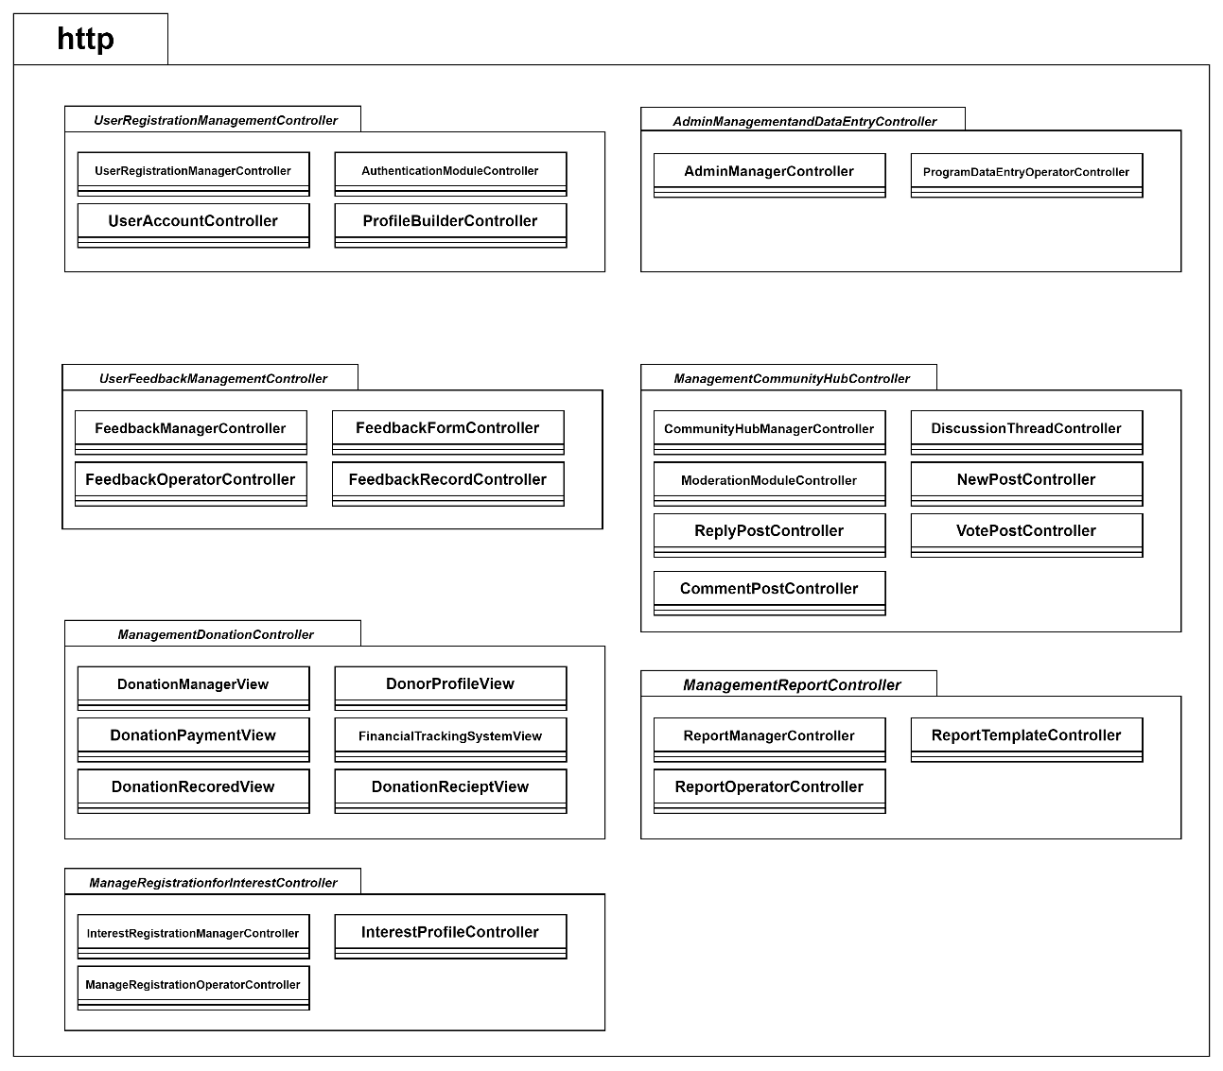

Figure ‎3.24 Business Services Layer Diagram of CollageEase

Table ‎3.25 User Registration Management Controller Class Table

|  |  |  |
| --- | --- | --- |
| Class Type | Conreoller class | |
| Responsibility | Facilitate the user registration process by interacting with users, collecting registration details, and handling the registration workflow. | |
| Attributes | Attributes Name | Attributes Type |
| Username  Password  Email  Role | Varchar  Varchar  Varchar  Varchar |
| Methods | Method Name | Description |
| collectUserRegistrationDetails()  validateUserRegistrationForm() | Prompt users to provide registration details through the registration form.  Validate user registration data. If issues exist, display user to Homepage. |
| Algorithm | collectUserRegistrationDetails():  registrationForm.promptUserForDetails()  validateUserRegistrationForm():  validationIssues = registrationForm.validateData()  if validationIssues is not empty:  registrationForm.displayValidationIssues(validationIssues)  else:  UserAlreadyRegsitered() | |

Table ‎3.26 Management Donation Controller Class Table

|  |  |  |
| --- | --- | --- |
| Class Type | Controller class | |
| Responsibility | Handle administrative tasks, manage user roles, oversee data entry processes, manage the community hub, and deal with reports. | |
| Attributes | Attributes Name | Attributes Type |
| Username  Password | Varchar  Varchar |
| Methods | Method Name | Description |
| manageAdminTasks()  processDataEntry(data)  viewReports()  manageCommunityHub()  overseeReports() | * Facilitate administrative tasks and user role changes. * Process data entered by DataEntryOperators. * View various reports generated by the system. * Manage community discussions, events, and members. * Oversee the generation and analysis of reports. |
| Algorithm | manageAdminTasks():  adminPanel.displayAdminOptions()  adminInput = adminPanel.getAdminInput()  if adminInput is "changeRole":  adminManager.changeUserRole()  elif adminInput is "approveDataEntry":  dataEntryManager.approveDataEntry()  elif adminInput is "viewReports":  reportManager.displayReports()  elif adminInput is "manageCommunityHub":  communityHubManager.manageCommunityHub()  processDataEntry(data):  dataEntryValidator.validateData(data)  if data is valid:  dataEntryProcessor.processData(data)  viewReports():  reportGenerator.generateReports()  reportViewer.displayReports()  manageCommunityHub():  communityHubManager.manageCommunityDiscussions()  communityHubManager.scheduleCommunityEvent()  overseeReports():  reportManager.analyzeReportData()  reportManager.presentReports() | |

Table ‎3.27 User Feedback Management Controller Class Table

|  |  |  |
| --- | --- | --- |
| Class Type | Controller class | |
| Responsibility | Collect and process user feedback, categorize feedback entries, and perform analysis. | |
| Attributes | Attributes Name | Attributes Type |
| UserID  FeedbackID  FeedbackTitle  FeedbackMessage  DateOfFeedbackMessage | Integer  Integer  Varchar  Varchar  Date |
| Methods | Method Name | Description |
| collectUserFeedback()  categorizeFeedback(feedback) | * Collect user feedback through the feedback form. * Categorize feedback entries into predefined categories for analyzethe data . |
| Algorithm | collectUserFeedback():  feedbackForm.promptUserForFeedback()  feedback = feedbackForm.getFeedbackData()  categorizeFeedback(feedback):  feedbackCategory = feedbackCategorizer.categorizeFeedback(feedback)  feedback.setCategory(feedbackCategory) | |

Table ‎3.28 Management Report Controller Class Table

|  |  |  |
| --- | --- | --- |
| Class Type | Controller class | |
| Responsibility | Generate, analyze, and present various reports related to CollageEase's performance and user engagement. | |
| Attributes | Attributes Name | Attributes Type |
| ReportType  ReportContent | Varchar  Text / graph |
| Methods | Method Name | Description |
| generateReports()  analyzeReportData()  presentReports() | * Generate reports based on user-specified criteria. * Analyze aggregated report data for insights. * Present reports to administrators and stakeholders. |
| Algorithm | generateReports():  reportGenerator.promptUserForReportType()  reportGenerator.generateReports()  analyzeReportData():  reportAnalyzer.analyzeReportData()  reportInsights = reportAnalyzer.getInsights()  displayInsights(reportInsights)  presentReports():  reportViewer.displayReports() | |

Table ‎3.29 Management Community Hub Controller Class Table

|  |  |  |
| --- | --- | --- |
| Class Type | Controller class | |
| Responsibility | Manage community discussions of questions and answer, events, and member interactions within the community hub. | |
| Attributes | Attributes Name | Attributes Type |
| CommunityID  ReferencePostID  PostDetails | Integer  Varchar  Varchar |
| Methods | Method Name | Description |
| collectUserFeedback()  categorizeFeedback(feedback) | * Collect user feedback through the feedback form. * Categorize feedback entries into predefined categories for analyzethe data . |
| Algorithm | collectUserFeedback():  feedbackForm.promptUserForFeedback()  feedback = feedbackForm.getFeedbackData()  categorizeFeedback(feedback):  feedbackCategory = feedbackCategorizer.categorizeFeedback(feedback)  feedback.setCategory(feedbackCategory) | |

Table ‎3.30 Management Donation Controller Class Table

|  |  |  |
| --- | --- | --- |
| Class Type | Controller class | |
| Responsibility | Handle donation-related processes, track donations, and manage donation campaigns. | |
| Attributes | Attributes Name | Attributes Type |
| DonationID  DonationDate  DonationTime  DonationAmount | Integer  Date  Varchar  Integer |
| Methods | Method Name | Description |
| processDonation(donationData)  manageDonationCampaign() | * Process and record donation transactions. * Manage donation campaigns and track their status. |
| Algorithm | processDonation(donationData):  donationValidator.validateDonationData(donationData)  if donationData is valid:  donationProcessor.processDonation(donationData)  manageDonationCampaign():  campaignManager.displayCampaigns()  campaignManager.createCampaign()  campaignManager.trackCampaignStatus() | |

Table ‎3.31 Manage Registration for Interest Controller Class Table

|  |  |  |
| --- | --- | --- |
| Class Type | Controller class | |
| Responsibility | This class is to handling those whose interest in some university/ program to register or join by the user to notify the staff marketing department | |
| Attributes | Attributes Name | Attributes Type |
| Email  InterestedProgram  RegistrationDate  ContactNumber | Varchar  Varchar  Date  Integer |
| Methods | Method Name | Description |
| collectInterestRegistrationDetails()  validateInterestRegistrationForm()  notifyMarketingDepartment() | * Prompt users to provide interest registration details. * Validate interest registration data. * Notify the marketing department of new interest requests. |
| Algorithm | collectInterestRegistrationDetails():  interestRegistrationForm.promptUserForDetails()  validateInterestRegistrationForm():  validationIssues = interestRegistrationForm.validateData()  if validationIssues is not empty:  interestRegistrationForm.displayValidationIssues(validationIssues)  else:  notifyMarketingDepartment()  notifyMarketingDepartment():  notificationService.sendNotificationToMarketingDepartment("New interest registration request") | |

### Middleware Layer

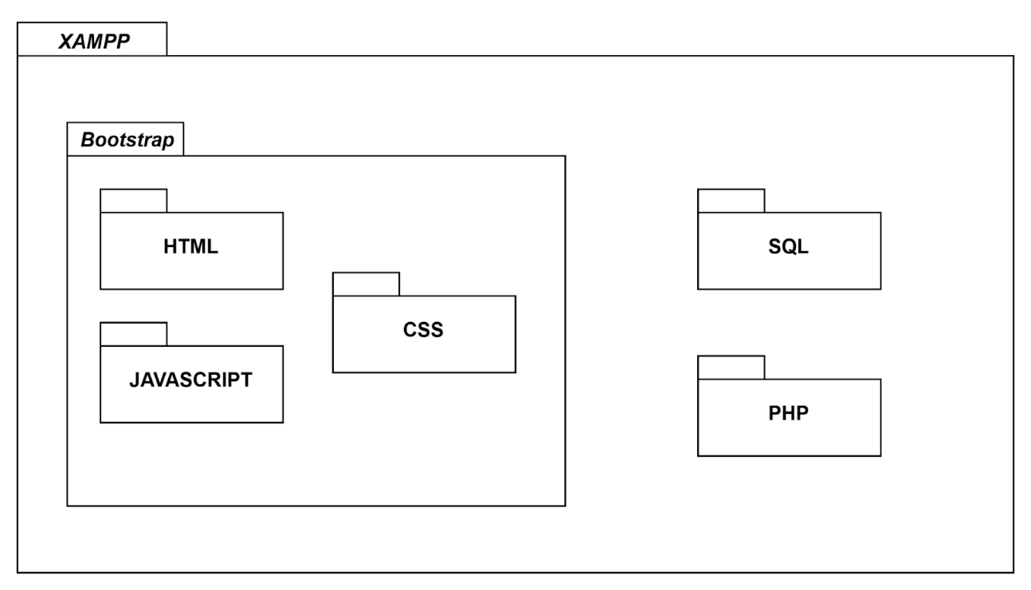

Figure ‎3.25 Middleware Layer Architecture

Table ‎3.32 Middleware Layer Architecture Description

|  |  |
| --- | --- |
| Package Name | **Description** |
| **XAMPP** | XAMPP provides a complete web development environment by bundling Apache, MySQL, PHP, and Perl together. It allows developers to easily set up a local server for testing and running web applications. |
| **Bootstrap** | Bootstrap offers a collection of CSS and JavaScript components that facilitate the creation of responsive and visually appealing web interfaces. It simplifies the development process by providing pre-built UI elements. |
| **HTML** | HTML is used to create the structure and content of web pages. It provides a markup language that defines the elements and their layout, allowing browsers to interpret and display the web content. |
| **CSS** | CSS enables the styling and visual presentation of web pages. It defines the appearance of HTML elements by specifying attributes such as colors, fonts, margins, and layout, enhancing the overall user experience. |
| **JavaScript** | JavaScript empowers web developers to add interactivity and dynamic functionality to their web pages. It enables client-side scripting, allowing for actions such as form validation, DOM manipulation, and asynchronous requests. |
| **SQL** | SQL provides a language for managing and manipulating relational databases. It allows developers to create, modify, and query databases, as well as define relationships between tables and manage data integrity. |
| **PHP** | PHP is a server-side scripting language that facilitates the development of dynamic web applications. It enables the processing and generation of web content on the server before sending it to the client's browser, making it highly versatile for web development. |

## MVC Package Relationship

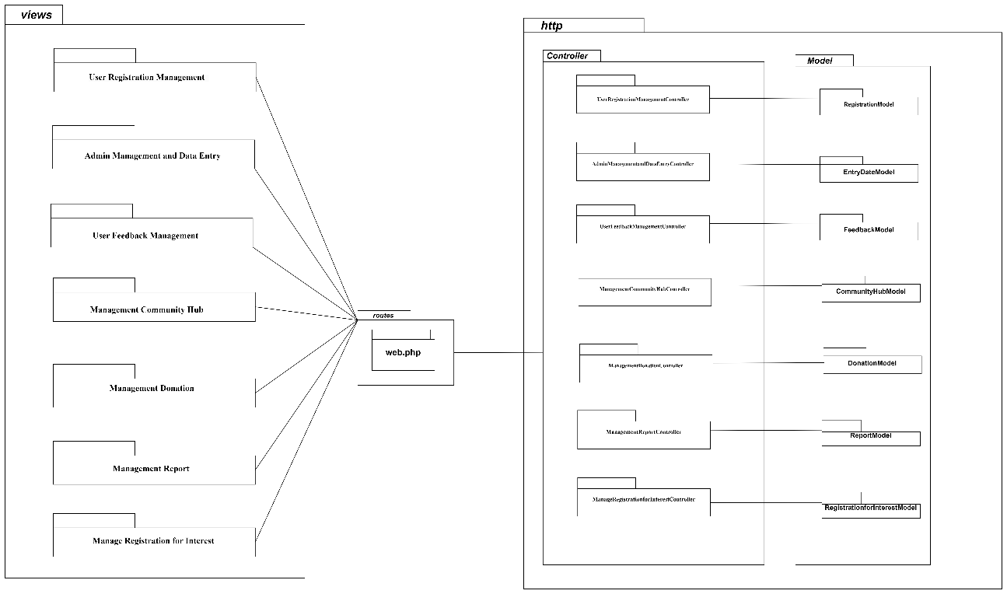

Figure ‎3.26 MVC Package Diagram

## Proof of Initial Concept

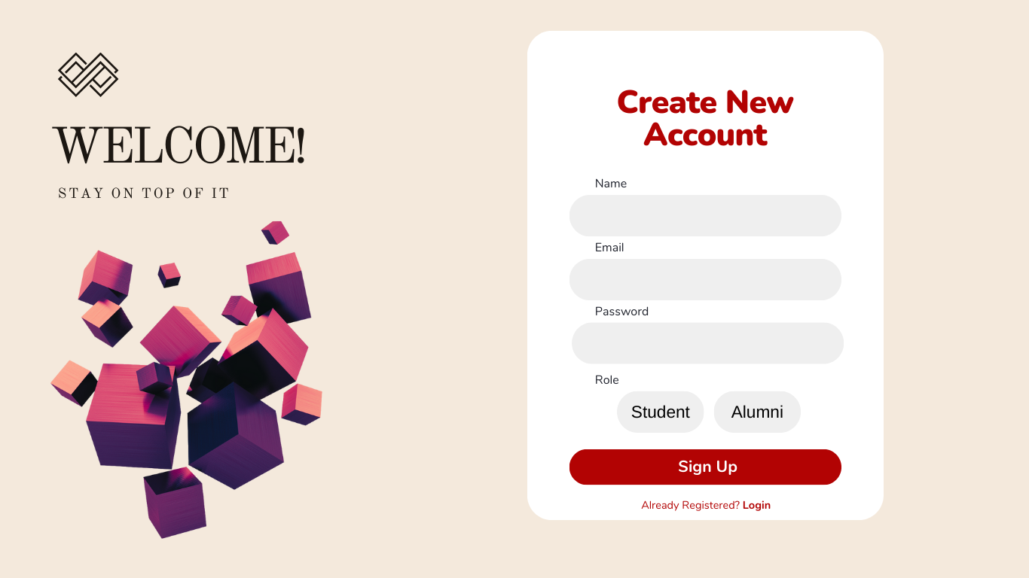

Figure ‎3.27 Prototype of log in page

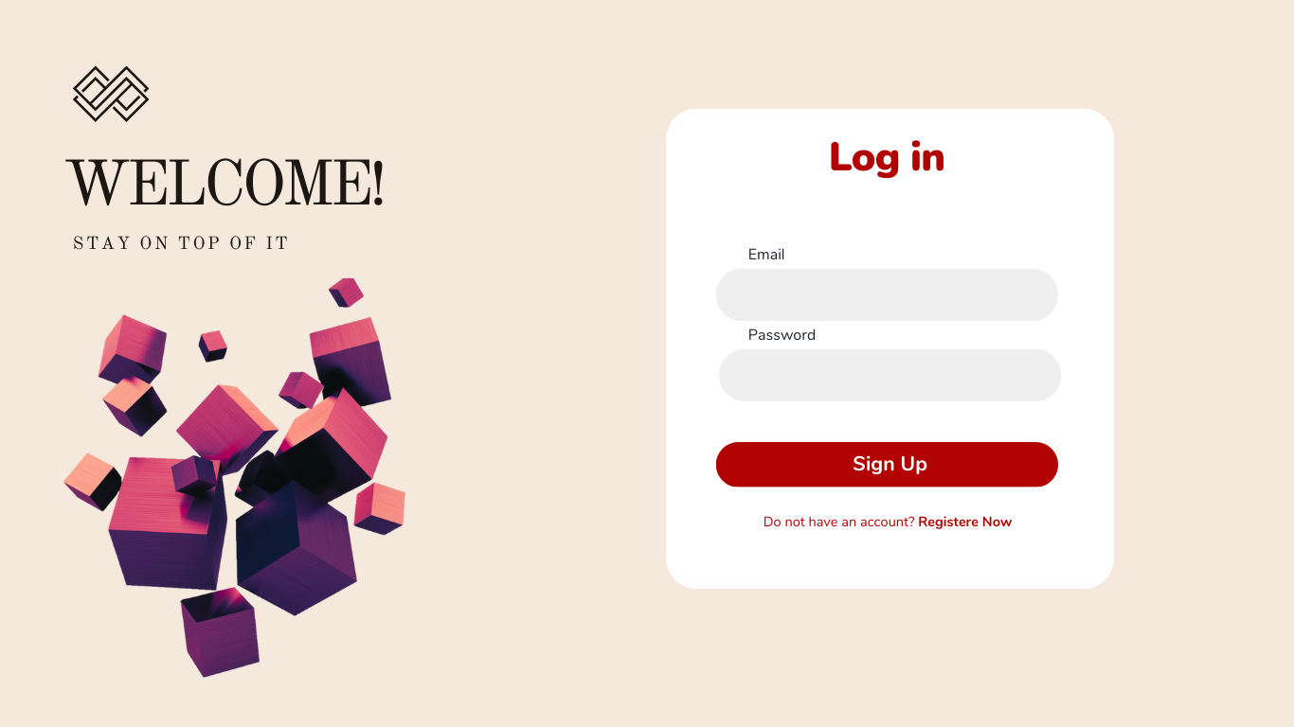

Figure ‎3.28 Prototype of registration page

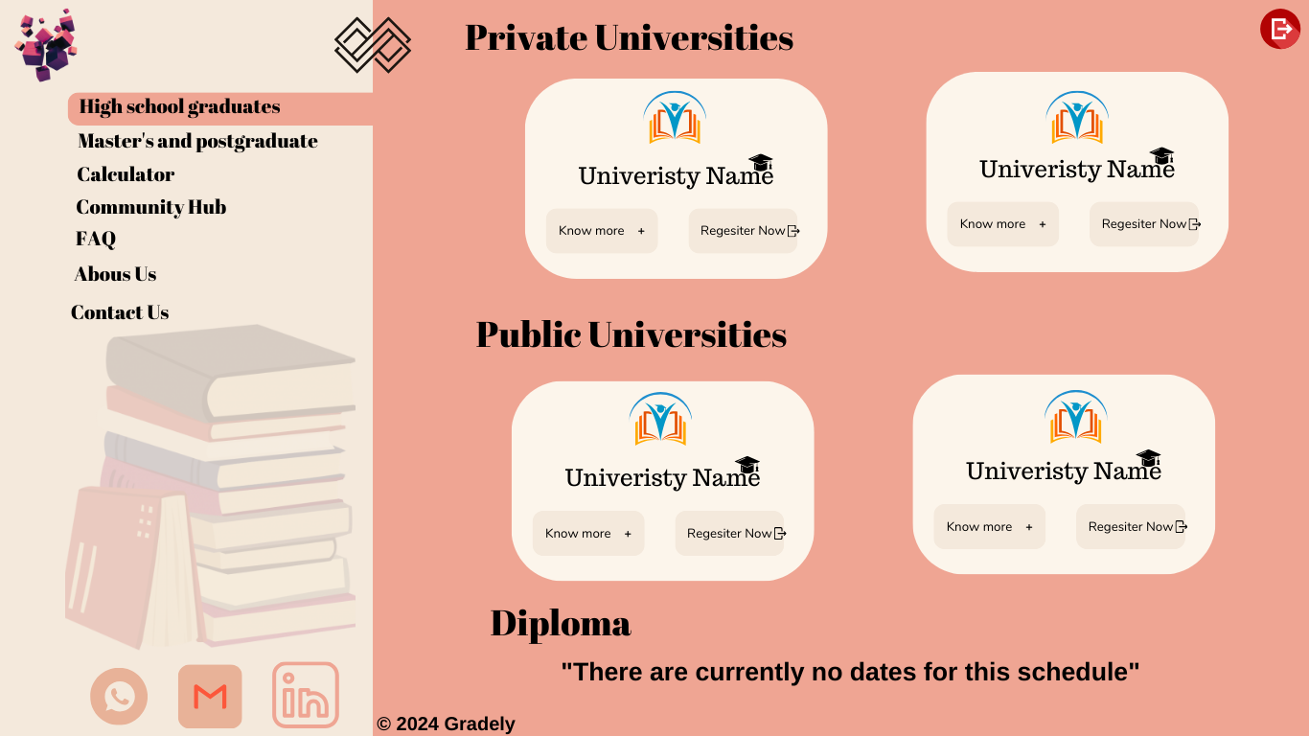

Figure ‎3.29 Prototype of High school graduates page

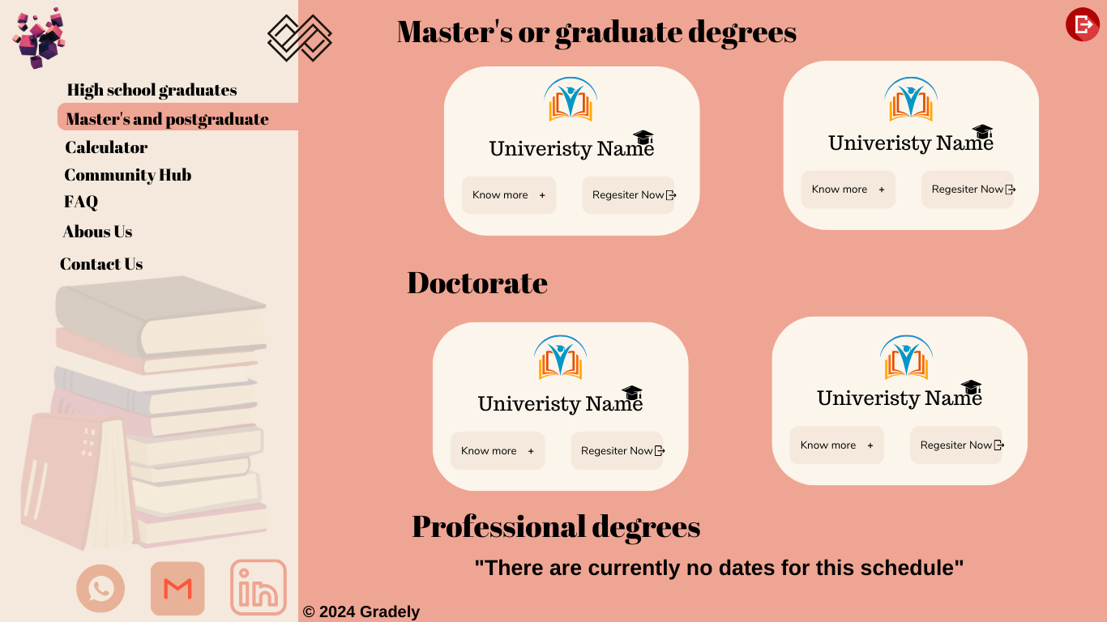

Figure ‎3.30 Prototype of Master's and postgraduate page

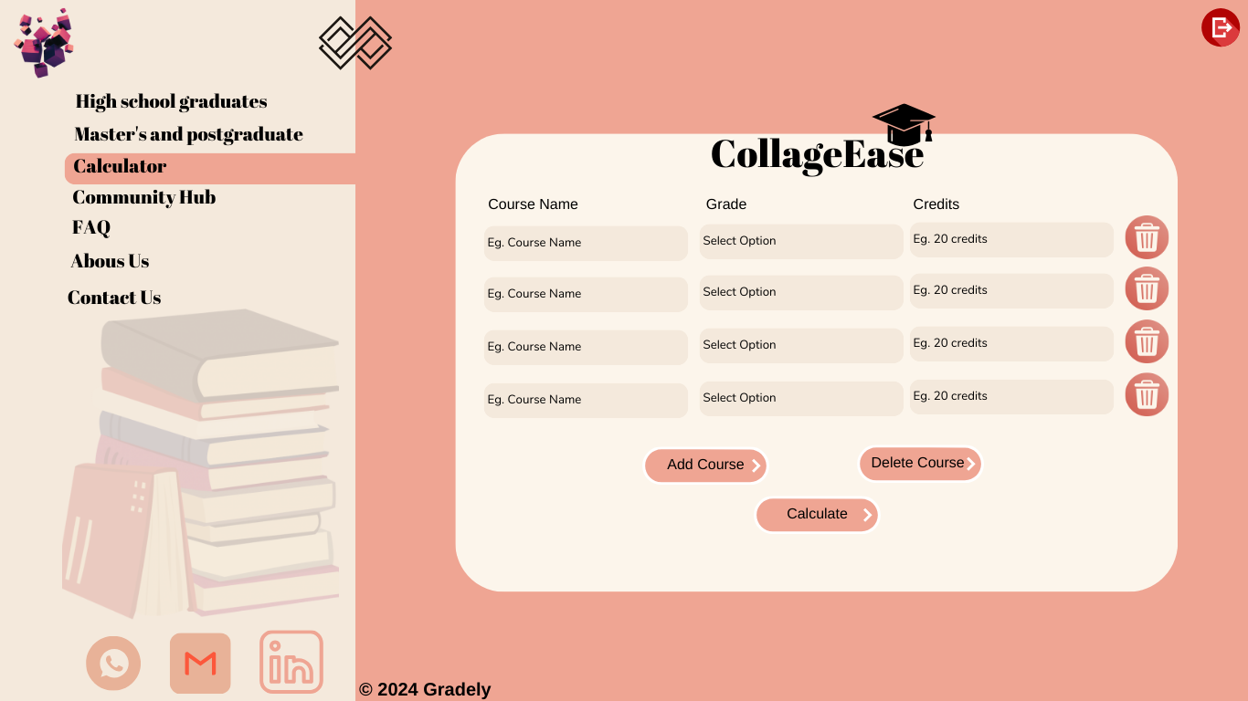

Figure ‎3.31 Prototype of Calculator page

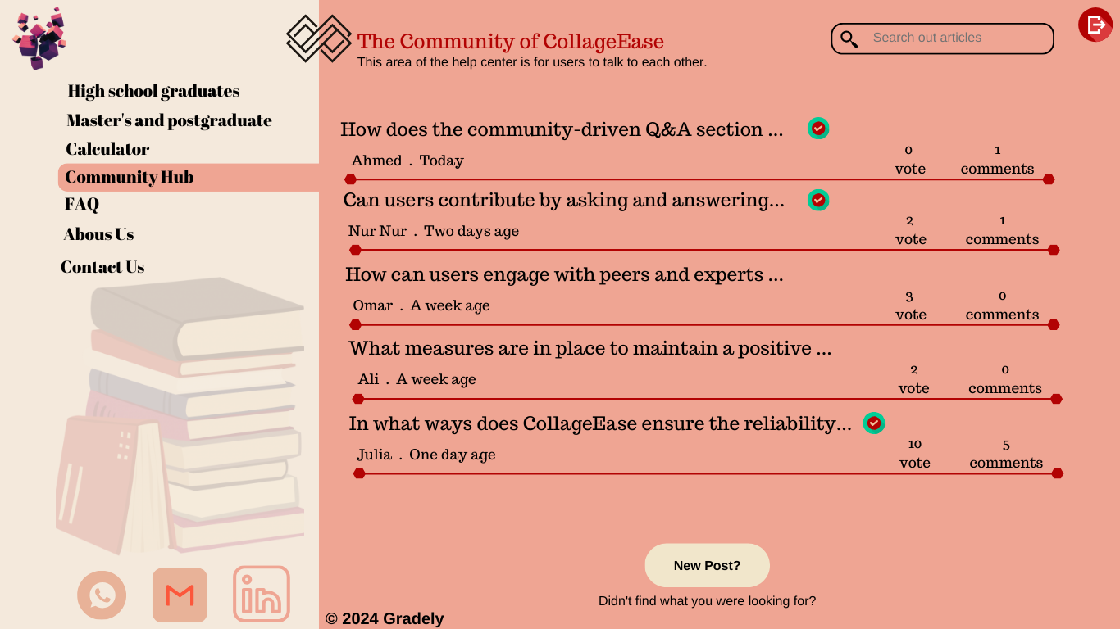

Figure ‎3.32 Prototype of Commynity Hub page

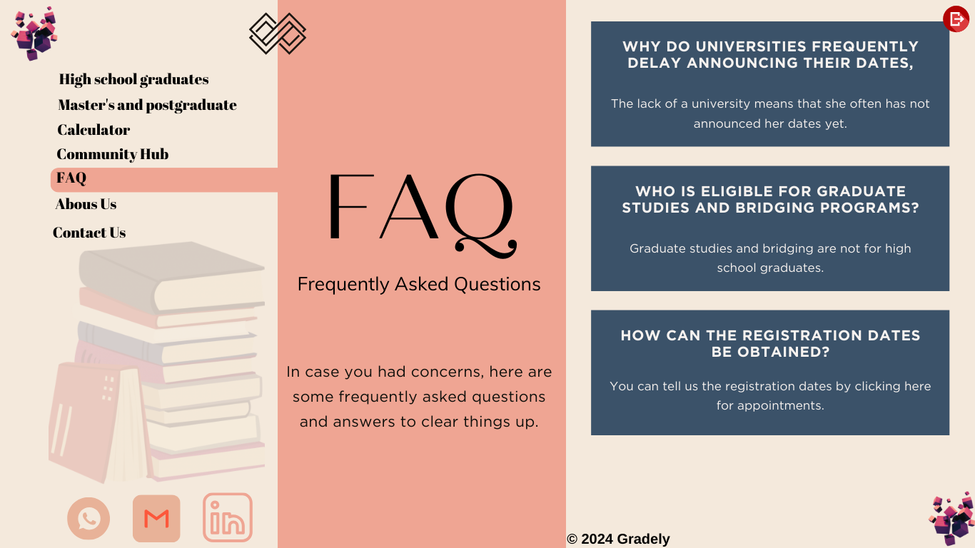

Figure ‎3.33 Prototype of questions and answers page



Figure ‎3.34 Prototype of about us page



Figure ‎3.35 Prototype of contact us page

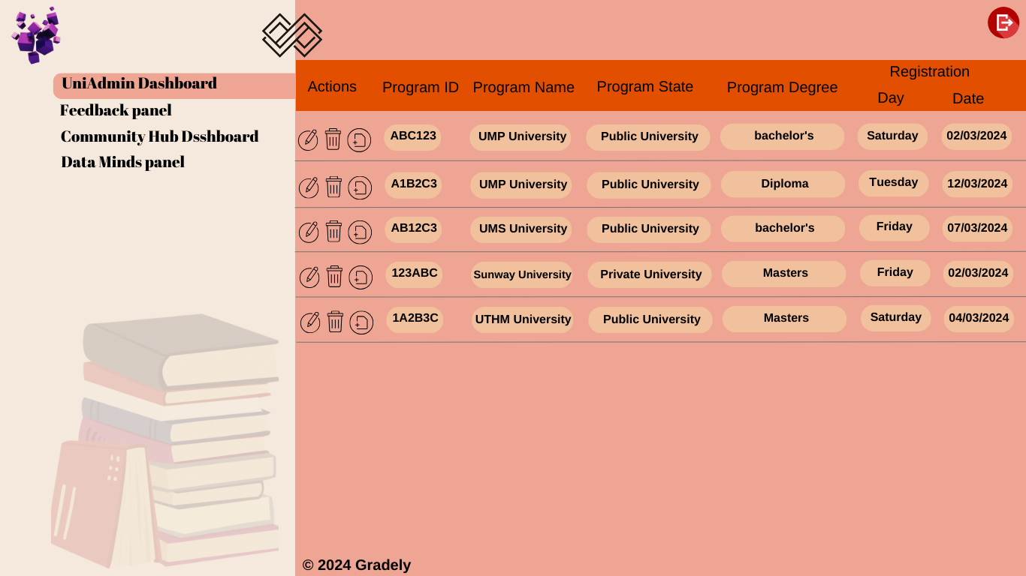

Figure ‎3.36 Prototype of Uni admin dashboard page

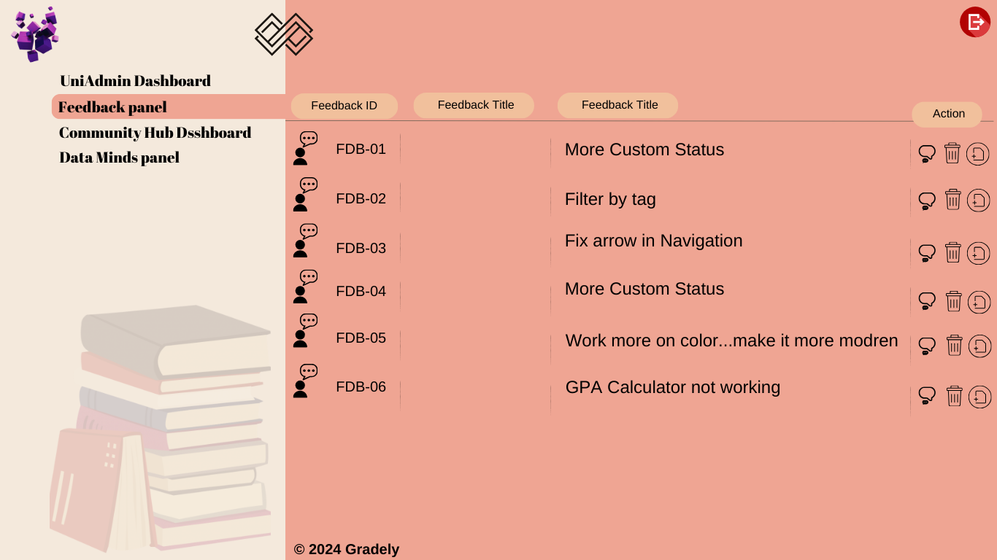

Figure ‎3.37 Prototype of Feedback panel page

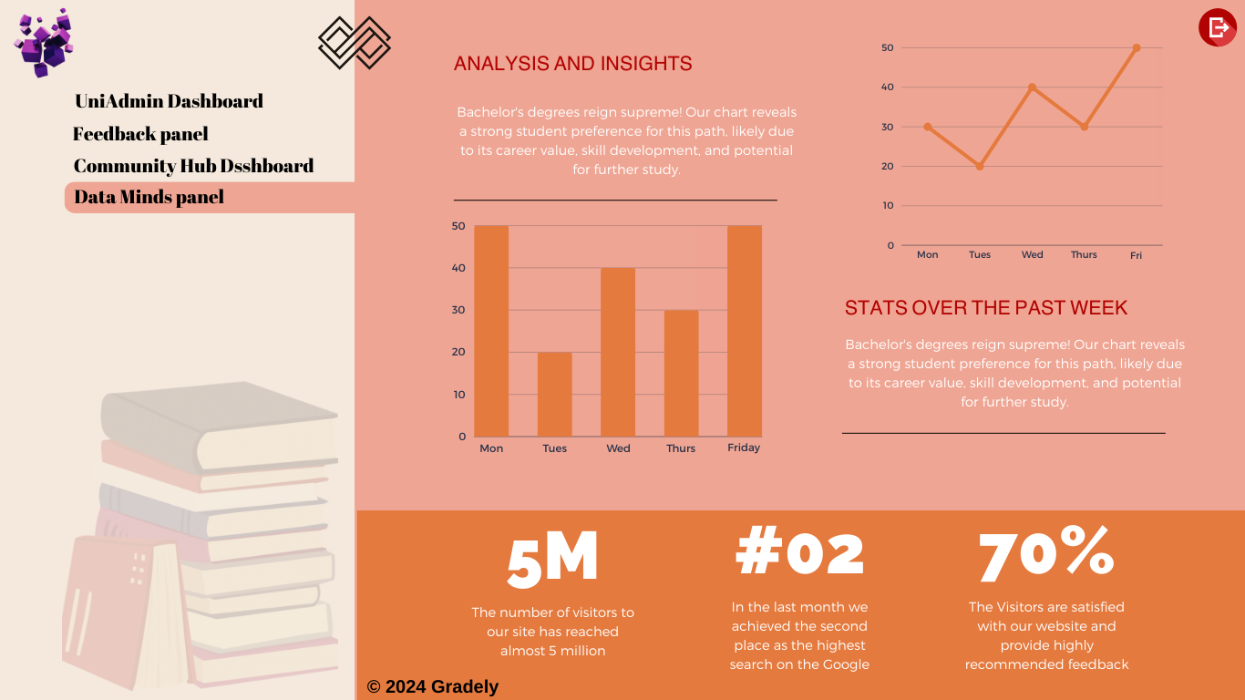

Figure ‎3.38 Prototype of Data minds panel page

## Test Plan

### Unit Testing

One of the methodologies used in software testing is unit testing. Unit testing is a fundamental practice in software development that involves testing individual units or components of a software application in isolation to ensure their correctness and reliability. A unit, in this context, refers to the smallest testable part of a program, such as a function, method, or class. The primary goal of unit testing is to validate that each unit of the software performs as designed, helping to identify and fix bugs early in the development process. The following are some of the ways that unit testing can help:

1. Improving the code's quality.
2. Create code that is dependable and reusable.
3. Make documentation easier to understand.
4. Make seamless integration possible.

Unit testing needs the use of a dummy. Mock objects are used to fill in the gaps in a programme. For example, there could be a function that requires variables or objects that have not yet been created. As a result, the role of the mocks is to fill in the blanks. There are three types of unit testing techniques:

1. White-Box testing: The tester should be familiar with a system's internal workings.
2. Black-Box testing: The tester is unaware of a system's internal functionality.
3. Gray-Box testing: This is a hybrid of white-box and black-box testing. The tester is familiar with a system's functioning, but not as much as white-box testing.

Unit testing is a critical practice in software development that promotes code reliability, early bug detection, and overall system stability. By systematically testing individual units of code in isolation, developers can build more robust and maintainable software applications.(Sawant et al., 2012)(Umar, 2019)

### User acceptance Testing

User Acceptance Testing (UAT) is a crucial phase in the software development life cycle (SDLC) that occurs after the completion of system and integration testing. It is the final stage before the software is deployed to production. The primary objective of UAT is to ensure that the developed system meets the users' expectations, aligning closely with their needs and business requirements.

If, during UAT, users discover discrepancies between the system's behavior and their expectations or if new requirements emerge, these issues can be addressed before the software goes live. UAT serves as a final check to ensure that the delivered solution not only meets the technical specifications but is also a practical and valuable tool for the end-users in their day-to-day operations.  
  
The following are the steps of user acceptance testing that tester should follow:

1. Knowledge gathering for test plan.
2. UAT scope.
3. UAT design.
4. UAT execution.
5. Confirm business objective.

In the context of CollageEase, the unit testing process will be meticulously implemented for each specific module, ensuring the reliability and functionality of individual components within the system. For example, in the User Registration Management System, the unit tests will validate the accuracy of user input handling, the seamless storage of user data in the database, and the proper execution of notification triggers. By adopting this approach, potential issues are identified and addressed early in the development cycle, contributing to the overall reliability and quality of the CollageEase system.(Otaduy & Diaz, 2017)

## Gantt chart

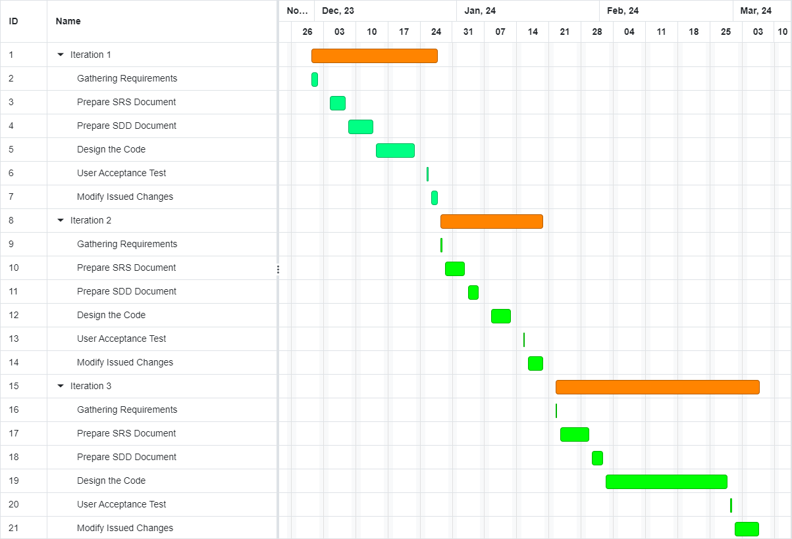

Figure ‎3.39 Gantt Chart of CollageEase System

# 

## Introduction

This chapter covers how the system was developed and how it was put into operation. Here, the specifics of this system's implementation were covered from the beginning to the end. For the user's benefit and comprehension, every screenshot and explanation included a step-by-step explanation. In addition, the User Acceptance Test (UAT) form was created to determine the system's performance. Users can review all functional and non-functional specifications to provide feedback. The system will benefit from this. As a result, tests must be conducted in order to evaluate the system's performance, and all of the results were recorded in the UAT form.

## IMPLEMENTATION

### Development Tools

Table ‎4.1 Tolls & Purpose

|  |  |
| --- | --- |
| **Tools** | **Purpose** |
| Canva | To design the graphical user interface (UI). |
| GitHub | To track the code and update the latest one. |
| Visual Studio | To write and build the code with a lot of extensions to smooth the process of writing the code. |

## Implementation

We should create a design of what we intend to develop before writing the code and creating the graphical user interface. The GUI design process results in the creation of some pages, some of which are listed here. The design's primary goal was to use less sentences and more images, icons, and other visual elements in place of text. By doing this, the user experience will be improved, and the users' pleasure will be attained.

### Designing The User Interface with Code

Achieving the envisioned graphical user interface (GUI) on the Visual Studio platform involves the strategic use of HTML and PHP for structure and functionality, respectively. CSS contributes to the visual appeal by styling elements. Additionally, JavaScript is seamlessly integrated to bring interactivity to the interface, allowing for dynamic features and a more engaging user experience. This combination of HTML, PHP, CSS, and JavaScript ensures a well-rounded approach to design, delivering both visual appeal and interactive functionality on the Visual Studio platform.

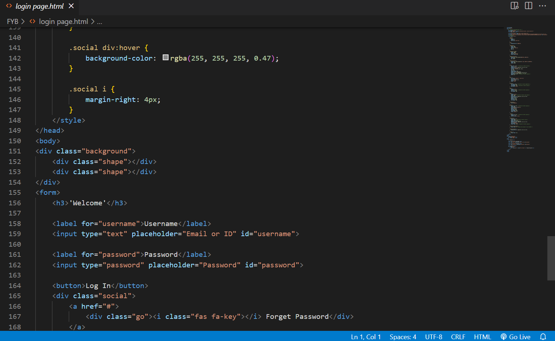

Figure ‎4.1 Primary resuilt of "Login page"

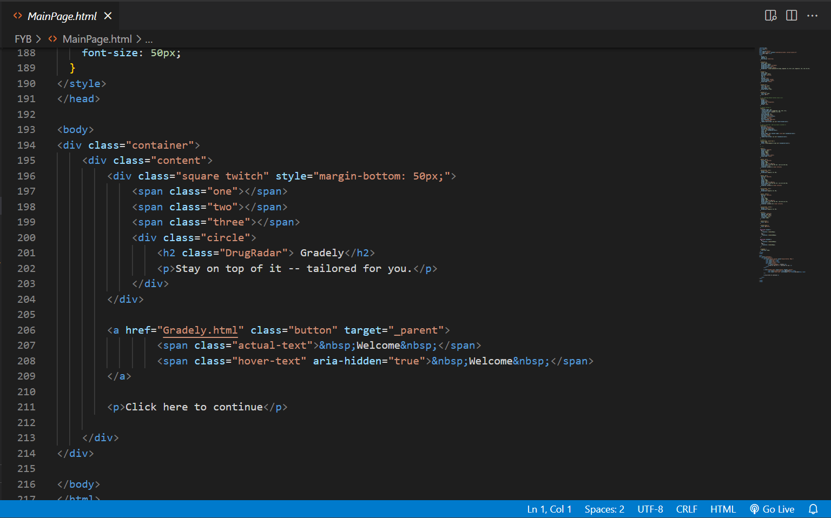

Figure ‎4.2 Primary resuilt of "Homepage"

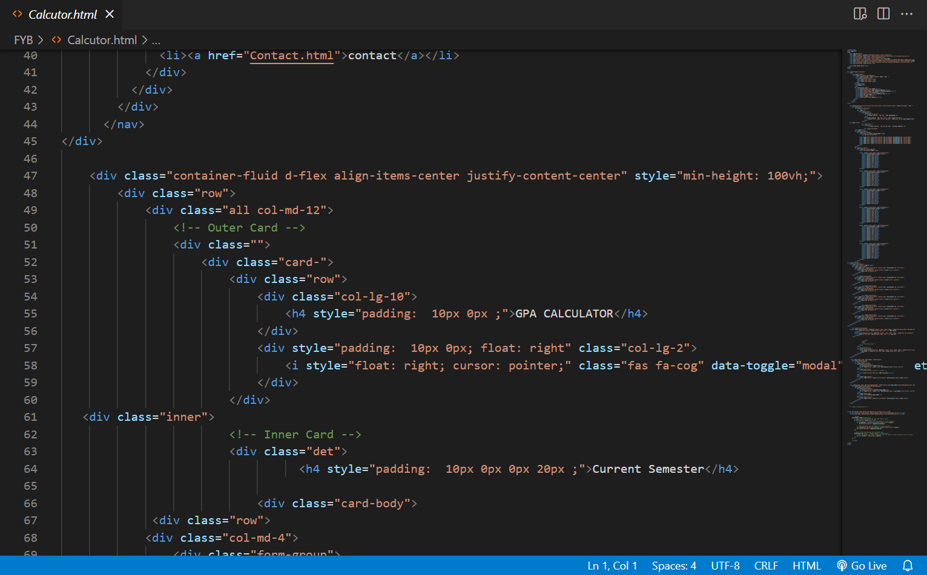

Figure ‎4.3 Primary resuilt of "Calculator page"

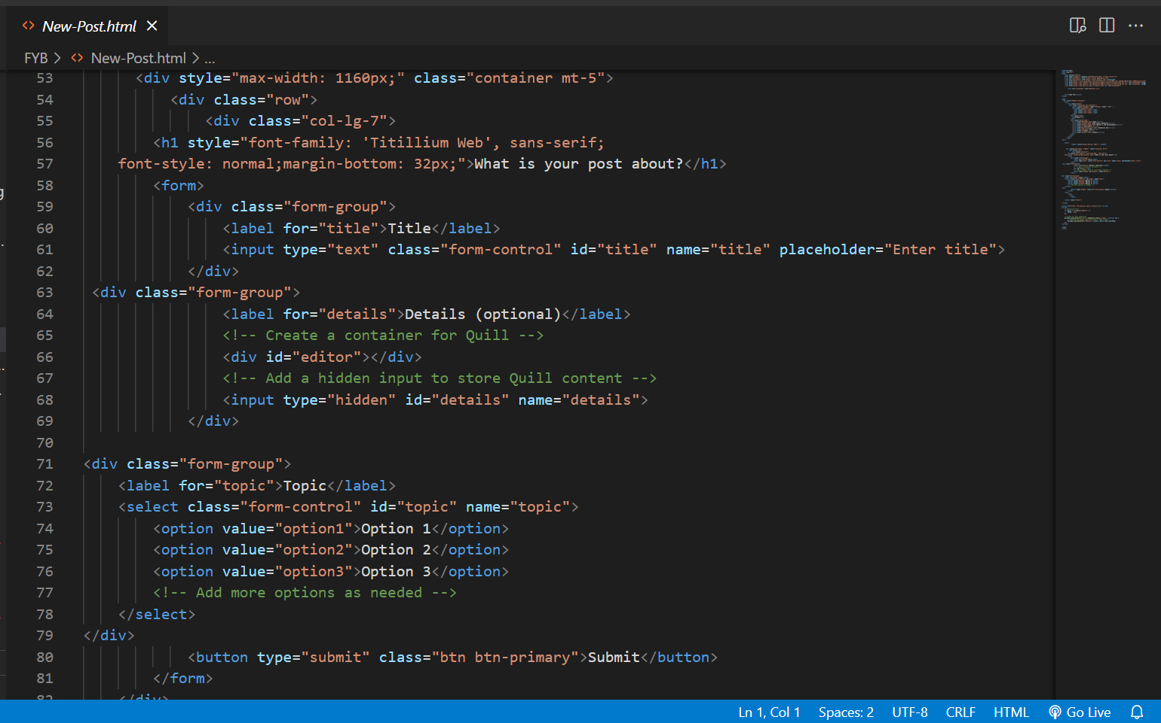

Figure ‎4.4 Primary resuilt of "New post / thread"

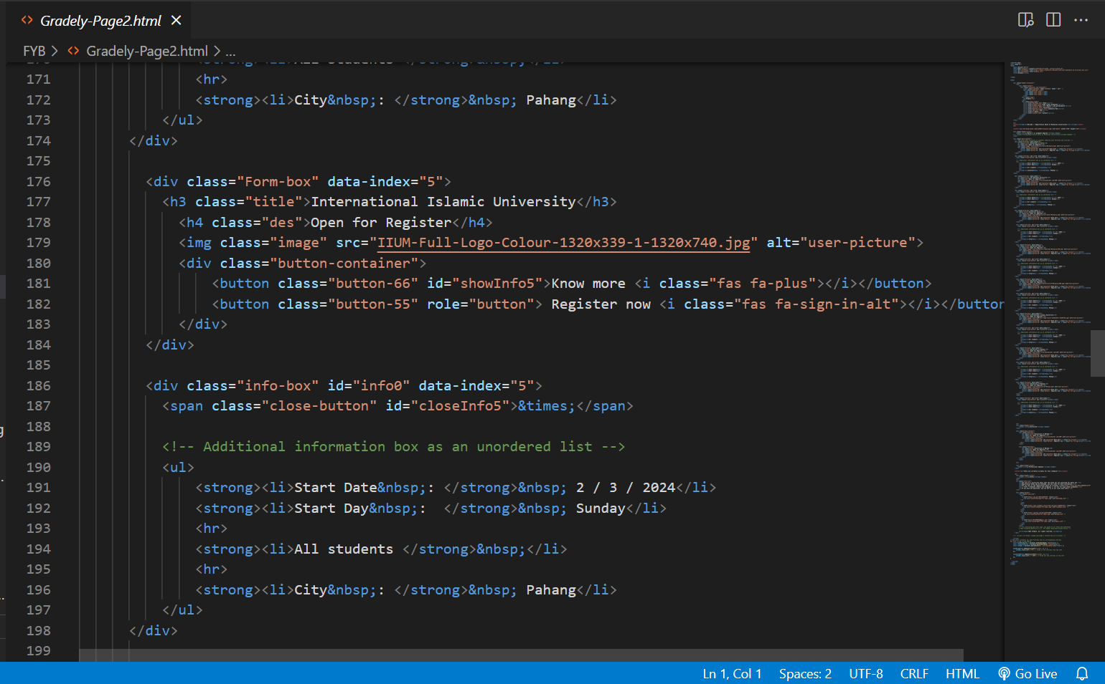

Figure ‎4.5 Primary resuilt of "Master University Program"

## Software Test

### Unit Test

### User Acceptance Testing

After users tried the website, they will have an interface with a survey form to fill up their experiment. The following questions are:

1. On a scale of 1 - 5, how satisfied are you with the overall design and layout of the website?
2. Rate the responsiveness of the website across different devices (e.g., desktop, mobile, tablet).
3. How likely are you to recommend this website to others?
4. Rate the speed and efficiency of the website in loading pages and processing tasks.

REFERENCES

Alexandrov, N., & Alexandrov, V. (2015). Computational science research methods for science education at PG level. Procedia Computer Science, 51(1), 1685–1693. https://doi.org/10.1016/j.procs.2015.05.305

Crooks, N. M., & Alibali, M. W. (2014). Defining and measuring conceptual knowledge in mathematics. Developmental Review, 34(4), 344–377. https://doi.org/10.1016/j.dr.2014.10.001

Gertler, M. S. (2003). Tacit knowledge and the economic geography of context, or the undefinable tacitness of being (there). Journal of Economic Geography, 3(1), 75–99. https://doi.org/10.1093/jeg/3.1.75

<https://www.yumpu.com/en/document/view/53572106/thesis-manual-2012-unikl-micet-universiti-kuala-lumpur>

https://www.researchgate.net/publication/328516721_Agile_Methodologies_in_Education_A_Review_Bringing_Methodologies_from_Industry_to_the_Classroom

F.O.ISINKAYE , Y.O.FOLAJAMI,B.A.OJOKOH “ Recommendation system: Principles, methods and evaluation”20 August 2015: https://www.sciencedirect.com/science/article/pii/S1110866515000341

Barnett, R. (2011). The Coming of the Ecological University. Oxford Review of Education, 37(4), 439-455.

Marginson, S. (2016). The Worldwide Trend to High Participation Higher Education: Dynamics of social stratification in inclusive systems. Higher Education, 72, 413-434.

Zainuddin, N., & Perera, C.J. (2019). Exploring the Role of Internet Technology in Higher Education: A Case of Malaysia. Education and Information Technologies, 24, 3053-3074.

Norman, D. A. (2013). The Design of Everyday Things: Revised and Expanded Edition. Basic Books.

Garrett, J.J. (2010). Elements of User Experience, The: User-Centered Design for the Web and Beyond. New Riders.

Krug, S. (2014). Don't Make Me Think, Revisited: A Common Sense Approach to Web Usability. New Riders.

Flick, U. (2018). An Introduction to Qualitative Research. Sage.

Creswell, J.W. (2013). Research Design: Qualitative, Quantitative, and Mixed Methods Approaches. Sage Publications.

Malaysian Ministry of Education. (2020). Malaysia Education Blueprint 2015-2025 (Higher Education).

https://www.techtarget.com/searchsoftwarequality/definition/unit-testing

Patton, M.Q. (2014). Qualitative Research & Evaluation Methods: Integrating Theory and Practice. Sage Publications.

Nielsen, J., & Loranger, H. (2006). Prioritizing Web Usability. New Riders.

Lazar, J., Feng, J.H., & Hochheiser, H. (2017). Research Methods in Human-Computer Interaction. Morgan Kaufmann.

Malaysian Qualifications Agency (MQA). (2018). Malaysian Qualifications Framework.

Preece, J., Sharp, H., & Rogers, Y. (2015). Interaction Design: Beyond Human-Computer Interaction. Wiley.

Beck, K., & Andres, C. (2004). Extreme Programming Explained: Embrace Change (2nd Edition). Addison-Wesley Professional.

Rubin, J., & Chisnell, D. (2008). Handbook of Usability Testing: How to Plan, Design, and Conduct Effective Tests. Wiley.

Khan, B.H. (2005). Managing E-Learning Strategies: Design, Delivery, Implementation, and Evaluation. Information Science Publishing.

Malaysian Higher Education System Overview by StudyMalaysia.com.

World Bank. (2020). The World Bank Annual Report 2020: Supporting Countries in Unprecedented Times.

UNESCO Institute for Statistics. (2019). Higher Education in Asia: Expanding Out, Expanding Up.